Guidelines for
Implementation of Common System Compensation Package
in the United Nations Secretariat

- Introduction

- In its resolution 70/244, the General Assembly approved the recommendations of the International Civil Service Commission (ICSC) regarding changes to the compensation package for internationally recruited staff members serving in the United Nations common system.

- The changes affect staff members in the professional and higher categories, field service category, and International General Service staff. Some of the main changes in the new compensation package are as follows:

- a unified salary scale without reference to dependency status;
- introduction of a spouse allowance for dependent spouses;
- introduction of a single parent allowance;
- changes in granting within grade increment;
- discontinuation of the language incentive;
- a revamped and streamlined education grant and adjustments to the special education grant entitlement;
- a new mobility incentive;
- changes to the amounts and structure of the hardship allowance;
- revision of the additional non-family hardship allowance to a non-family service allowance;
- discontinuation of the non-removal element of the mobility and hardship allowance;
- changes in eligibility for repatriation grant;
- discontinuation of accelerated home leave except in D and E duty stations not falling within the rest and recuperation framework;
- a revised relocation package that includes relocation travel, settling-in grant (formerly assignment grant) and relocation shipment of household goods.

- In addition and in recognition of the acquired rights for serving staff with respect to certain allowances, the General Assembly approved specific transitional arrangements where applicable. Other benefits and entitlements such as annual/sick leave, family visit travel, rest and recuperation framework and danger pay remain unchanged.

- The approved changes will be implemented in phases from 2016 through 2018 as per table below. The current guidance reflects practical information related to the changes that are being implemented as of 1 July 2016, including approved transitional and special measures where applicable. Therefore, this guidance covers the following benefits and entitlements: Hardship allowance, mobility incentive, discontinuation of non-removal allowance, non-family service allowance, repatriation grant, accelerated home leave, settling-in grant, and relocation shipment. Guidance on changes that will be implemented in subsequent periods will be communicated separately prior to their implementation. Please visit http://commonsystem.org/cr/ for additional details on the new compensation package.

- Retroactive adjustments may be made to elements of the new compensation package with delayed implementation i.e. mobility incentive, discontinuation of non-removal allowance and salary related elements.

Implementation timeline of new compensation package

Benefit and entitlement | Effective date as per GA resolution 70/244 | Implementation date as per Secretary-General’s Note (A/70/896)*
Unified salary scale | 1 January 2017 | 1 September 2017*
Spouse allowance | 1 January 2017 | 1 September 2017*
Single parent allowance | 1 January 2017 | 1 September 2017*
Within grade increment | 1 January 2017 | 1 September 2017*
Discontinuation of language incentive | 1 January 2017 | 1 September 2017*
Education grant and Special education grant | School year in progress as of 1 January 2018 | School year in progress as of 1 January 2018
Mobility incentive | 1 July 2016 | 1 November 2016*
Discontinuation of the non-removal allowance | 1 July 2016 | 1 November 2016*
Repatriation grant | 1 July 2016 | 1 July 2016
Discontinuation of accelerated home leave except in D and E duty stations not falling within the rest and recuperation framework | 1 July 2016 | 1 July 2016
Hardship allowance | 1 July 2016 | 1 July 2016
Non-family service allowance | 1 July 2016 | 1 July 2016
Settling-in grant | 1 July 2016 | 1 July 2016
Relocation shipment (including unaccompanied shipment) | 1 July 2016 | 1 July 2016
* The Secretary-General’s Note (A/70/896) is yet to be considered by the General Assembly. Should the General Assembly not approve the Secretary-General's proposal to align the effective dates with the actual implementation dates, changes will need to be implemented retroactively to the effective General Assembly mandated dates.

- This guidance is intended as a practical tool for human resources practitioners and staff members at large in the implementation of the changes in the compensation package that come into force on 1 July 2016. They are a supplement and do not replace the provisions of the relevant Staff Rules and Staff Regulations and administrative instructions. They should be read in conjunction and with primary reference to the relevant promulgated administrative issuances. In the event of any discrepancy, the Staff Rules and Staff Regulations and administrative instructions prevail.

- Hardship allowance

- The ICSC will continue to classify duty stations into six categories by level of difficulty: H and A to E. H duty stations are headquarters duty stations and similarly designated duty stations where the United Nations has no developmental or humanitarian assistance programmes, or locations in countries that are members of the European Union. A to E duty stations are considered field duty stations with those classified as A representing the least difficult and E representing the most difficult conditions of life and work.

Eligibility

- Staff members in the professional and higher categories and in the field service category and internationally recruited general service staff holding a fixed-term, continuing, permanent or temporary appointment and appointed/assigned to a duty station with a hardship category of B, C, D, and E will continue to be entitled to a hardship allowance. The allowance shall be payable from the beginning of the appointment/assignment to the duty station with a hardship classification of B, C, D or E irrespective of the duration of the staff members appointment/assignment to the duty station or change of the hardship classification to a category that gives rise to the allowance. The hardship allowance is not payable in duty stations classified as H and A.

Amount of the allowance

- Effective 1 July 2016, the hardship allowance is payable based on a flat rate differentiated and grouped by grade level and hardship classification as per the table below. The new hardship allowance no longer distinguishes based on dependency status. Therefore, a change in dependency status as of 1 July 2016 does not trigger an adjustment in the amount of the hardship allowance. The old hardship allowance differentiated by grade level and dependency status shall be discontinued effective 30 June 2016 COB.

Hardship allowance effective 1 July 2016
(Annual amounts in United States dollars) 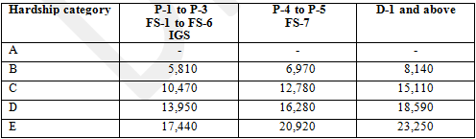

Change in hardship classification

- Where a change in the hardship classification of a duty station is made by the ICSC, the amount of the hardship allowance shall be adjusted accordingly either upwards or downwards or discontinued in the case of a change to a hardship classification of A or H. Changes in the hardship classification are implemented as of the effective date of the new hardship classification as approved by the ICSC.

- Where a change in the grade level of a staff member occurs, it may result in an adjustment of the hardship allowance provided the change in level results in a move to a different level grouping as reflected in the table above. A change in grade level as a result of a promotion, temporary promotion, special post allowance, temporary grade or demotion that results in a different level grouping as per the table above shall trigger an adjustment in the amount of the hardship allowance. Typically such triggers will be a change in grade levels at the P-4, FS-7 and D-1 levels. Such adjustments shall be effective as of the date of the change.

Assignment/reassignment including transfer/secondment/loan

- A staff member who is on assignment with payment of post adjustment applicable to the duty station or is reassigned to a duty station with a hardship classification of B to E shall be entitled to payment of the corresponding hardship allowance as of the effective date of assignment/reassignment.

- Non-family service allowance

- Effective 1 July 2016, a non-family service allowance is payable to staff serving in non-family duty stations. It replaces the additional non-family hardship allowance which will be payable until 30 June 2016 COB. The purpose of the non-family service allowance is to compensate for the increased financial and psychological hardship incurred owing to the involuntary separation of staff from families. It also acts as an incentive for staff to undertake assignments at non-family duty stations.

Eligibility

- The non-family service allowance is payable to staff members in the professional and higher categories and field service category and internationally recruited general service staff holding a fixed-term, continuing, permanent or temporary appointment and appointed/assigned to a duty station designated as non-family by the Chairman of the ICSC. The non-family service allowance is payable irrespective of the duration of the appointment/assignment in the duty station designated as non-family. A staff member on travel status and in receipt of daily subsistence allowance is not eligible for payment of the non-family service allowance for the duty station of the temporary assignment. However, the staff member may continue to be eligible for payment of the non-family service allowance if he/she is entitled to the allowance on account of the parent duty station being designated as a non-family duty station.

Amount of the allowance

- The amount of the non-family service allowance is differentiated by recognised family status with an amount for staff with dependents and a different amount for staff without dependents. Unlike the additional non-family hardship allowance, the amount of the non-family service allowance makes no differentiation based on grade level.

Non-family service allowance effective 1 July 2016
(Annual amounts in United States dollars)
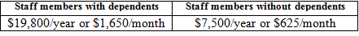

Staff members married to each other

- Where two eligible staff members are married to each other, including in another Organisation of the United Nations common system and both are assigned to a non-family duty station, each will be paid the non-family service allowance at the rate for staff members without dependents. If there are one or more dependent children, the allowance will be paid at the rate for staff members with dependents to the staff member in respect of whom the child or children are recognized as dependants.

- The non-family service allowance will be payable in cases where an eligible staff member’s spouse is employed by a non-UN entity and working at the duty station. However, such staff will not be eligible for initial travel, DSA and shipment of effects to duty station in respect of spouse, home leave travel or other related entitlements in respect of his/her spouse.

Discontinuation of the allowance

- Payment of the non-family service allowance shall be suspended for the duration of the presence of a staff member’s eligible dependents in a non-family duty station regardless of the duration of the presence and irrespective of whether the presence of the eligible dependents in the non-family duty station has been exceptionally authorised by the Under-Secretary-General for Safety and Security on behalf of the Secretary-General. Similarly, the non-family service allowance shall be suspended for the duration of the presence of eligible dependents in the duty station who are nationals of the country of the duty station.

- Payment of the non-family service allowance shall be discontinued upon a change in the status of a duty station from non-family to family, subject to any transitional arrangements that may be authorised by the Office of Human Resources Management or upon reassignment of a staff member from a non-family to a family duty station.

- Mobility Incentive

- Effective 1 July 2016, a new mobility incentive is introduced. It replaces the mobility allowance which may be payable to eligible staff members until 30 June 2016. The new mobility incentive will be implemented on 1 November 2016 with an effective date of 1 July 2016. Staff members who meet the eligibility requirements on or after 1 July 2016 will be eligible for payment of a mobility incentive.

Eligibility

- The mobility incentive is payable to staff members in the professional and higher categories, field service and internationally recruited General Service staff appointed/assigned to a duty station classified as A to E for a period of one year or longer and who meet the following conditions:

- The staff member must have five years of prior continuous service on a fixed-term, continuing or permanent appointment as a staff member in the United Nations or another Organisation of the United Nations Common System;
- The staff member is on the second assignment/appointment and in a duty station classified as A to E;
- Periods of service on special leave without pay shall not break continuity of service. However, periods of special leave without pay of more than one full month (30 days) shall not be counted towards the five years of continuing service;
- Periods of service under a temporary appointment shall not be considered for purposes of continuity of service.

- Determining the number of assignments for the purposes of the mobility incentive shall be counted in accordance with the provisions of the administrative instruction on mobility and hardship scheme.

- The mobility incentive is not payable in Headquarter duty stations. However, qualifying service at a Headquarter duty station of one year or longer shall be counted for purposes of determining the count of assignments for the mobility incentive. The count of assignments under the mobility allowance will be honoured for purposes of the mobility incentive.

- Like the mobility allowance, the mobility incentive is payable until the staff member reaches a total period of five continuous years at the same duty station. However, a staff member in receipt of the mobility incentive who is explicitly requested by the Organisation to remain at the same duty station or in the case of compelling humanitarian reasons may exceptionally be paid the mobility incentive for one additional year, but in no case for more than a total of six years at the same duty station.

Amount of the mobility incentive

- The mobility incentive is payable at a flat rate differentiated by grade level and number of assignments as per the table below. It does not distinguish based on dependency status. Therefore, a change in dependency status on or after 1 July 2016 does not trigger an adjustment in the amount of the mobility incentive. The mobility incentive is increased by 25 percent upon the 4th assignment and by 50 percent on the 7th assignment.

Mobility incentive effective 1 July 2016
(Annual amounts in United States dollars)
Assignment number | Additional amounts | Group 1  (P-1 to P-3)  (FS-1 to FS-6)  (IGS) | Group 2  (P-4 to P-5)  (FS-7) | Group 3  (D-1 and above)
2 to 3 | None | 6,500 | 8,125 | 9,750
4 to 6 | 25 per cent | 8,125 | 10,156 | 12,188
7+ | 50 per cent | 9,750 | 12,188 | 14,625

Transitional measure

- As a transitional measure, staff members in the professional and higher categories, the field service category and international general service staff holding an appointment other than a temporary appointment and in receipt of the mobility allowance, on 30 June 2016 will continue to receive the allowance for up to five continuous years at the same duty station, including at duty stations classified as H, or until the staff member moves to another duty station for a period of one year or longer, whichever is earlier. The allowance shall be payable on the basis of the amounts of the mobility allowance in effect as of 30 June 2016 as per table below.

Mobility allowance as of 30 June 2016
(Annual amounts in United States dollars)

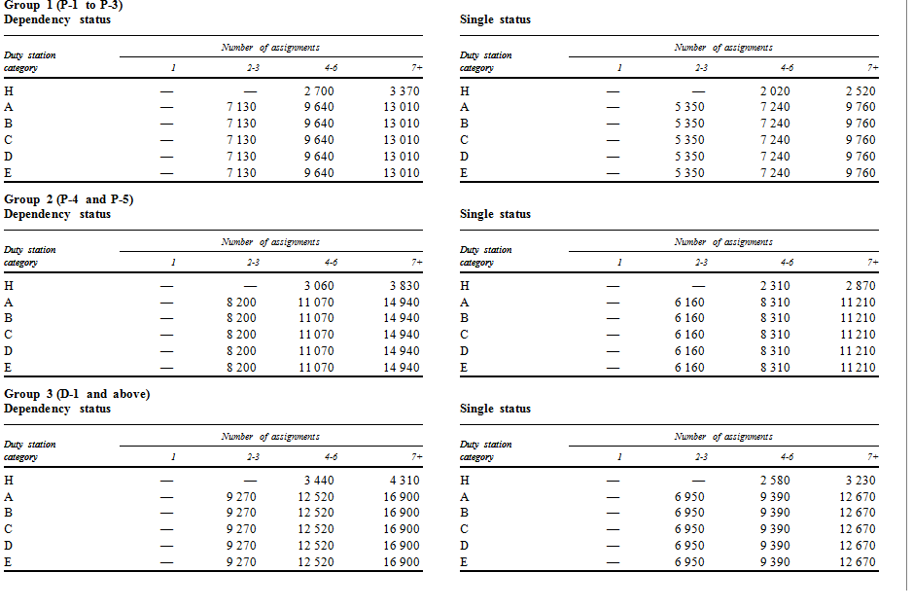

- In connection with the transitional measure, a staff member in receipt of the mobility allowance who is explicitly requested by the Organisation to remain at the same duty station or in the case of compelling humanitarian reasons may exceptionally be paid the mobility allowance for one additional year for a maximum of six years at the same duty station.

- Where a staff member is in receipt of the mobility allowance as a transitional measure and moves to a new duty station classified as A to E, on or after 1 July 2016, for a period of one year or more the staff member may be eligible for the mobility incentive and corresponding amounts provided all conditions are met. The mobility allowance shall not be payable in the new duty station.

- Where a staff member is in receipt of the mobility allowance as a transitional measure, a change in the staff member’s personal grade to the P-4, FS-7 and D-1 levels and/or family status will trigger a change in the amount of the mobility allowance as of the effective date of change.

- Where a transitional measure is in force and prior to the implementation of the unified salary scale, the payment of the allowance shall be based on whether the staff member is receiving salary at the dependent or single rate. Upon implementation of the unified salary scale, payment of the allowance at the dependent rate shall be based on whether the staff member is in receipt of any one of the following: transitional allowance, spouse allowance, single parent allowance or child allowance.

- In connection with the transitional measure, periods on special leave without pay of more than 30 days are not included in the five continuous year period during which a staff member may be in receipt of the mobility allowance.

- Where a staff member is on assignment to a different duty station for one year or longer, on or after 1 July 2016, and a lien is maintained against a position at the parent duty station, he/she shall be ineligible for payment of the mobility allowance upon return to the parent duty station. Upon return to the parent duty station, the staff member may be eligible for the mobility incentive provided all conditions are met, including that the service is in a duty station classified as A to E.

- Where a staff member from a UN common system Organisation is on inter-agency loan or secondment on or after 1 July 2016 and the service is in the same duty station and he/she was in receipt of the mobility allowance in the parent Organisation, he/she shall continue receiving the allowance for the remaining period not to exceed five consecutive years at the same duty station.

- Where a staff member from a UN common system Organisation is on inter-agency secondment or transfer or loan on or after 1 July 2016 and the service is in a different duty station, he/she may be eligible for the mobility incentive provided all conditions are met.

- Non-removal allowance

- Effective 1 July 2016, the non-removal element of the mobility and hardship scheme is discontinued. The non-removal allowance shall no longer be available to staff members in the professional and higher categories, field service category and internationally recruited general service staff holding a fixed-term, continuing or permanent appointment and appointed/ assigned/transferred/reassigned to a duty station for a period of one year or longer on or after 1 July 2016 and opt for unaccompanied shipment of personal effects and household goods. Discontinuation of the non-removal allowance will be implemented on 1 November 2016 with an effective date of 1 July 2016.

Transitional measure

- As a transitional measure, staff members in the professional and higher categories and field service category and internationally recruited general service staff holding a fixed-term, continuing or permanent appointment who are appointed/assigned/transferred/reassigned for a period of one year or longer prior to 1 July 2016 and who opt for non-removal of personal effects and household goods shall continue to receive the non-removal allowance for up to five years of consecutive service in the same duty station or until he/she moves to a different duty station for a period of one year or longer, whichever is earlier.

- During the transitional period, the non-removal allowance amounts in effect as of 30 June 2016 COB shall remain applicable as per table below.

Non-removal allowance as of 30 June 2016
(Annual amounts in United States dollars)
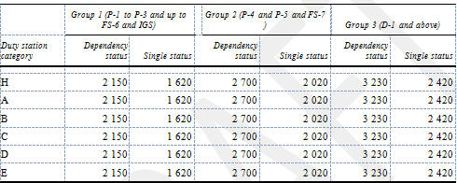

- Where a staff member is in receipt of the non-removal allowance during the transitional period, a change in the staff member’s personal grade to the P-4, FS-7 and D-1 levels and/or family status will trigger a change in the amount of the non-removal allowance, as appropriate, as of the effective date of the change.

- During the transitional period and prior to the implementation of the unified salary scale, the payment of the allowance shall be based whether the staff member is receiving salary at the dependent or single rate. Upon implementation of the unified salary scale, payment of the allowance at the dependent rate shall be based on whether the staff member is in receipt of any one of the following: transitional allowance, spouse allowance, single parent allowance or child allowance.

- During the transitional period, the non-removal allowance shall cease when a staff member is in receipt of the allowance and proceeds on assignment to another duty station for a period of one year or longer and maintains a lien against a post in the parent duty station. The non-removal allowance shall not be payable upon completion of the assignment and return to the parent duty station.

- During the transitional period, where a staff member in receipt of the non-removal allowance at the parent duty station proceeds on temporary assignment to another duty station for a period of less than one year and maintains a lien against a post in the parent office, the non-removal allowance shall be suspended for the duration of the temporary assignment and payment shall resume upon return to the parent duty station. The period of payment of the non-removal allowance shall be extended, as appropriate, by the same period that the staff member was on temporary assignment subject to the maximum period of payment of the allowance of five years at the same duty station including the period prior to and after the temporary assignment.

- Where a staff member is on temporary assignment to a different duty station prior to 1 July 2016 and the assignment is for a period of less than one year and he/she is in receipt of non-removal allowance at the parent duty station, the allowance shall be suspended for the duration of the temporary assignment. However, where the temporary assignment is subsequently extended to reach a period of one year or longer, the allowance is not payable upon return to the parent duty station.

- Where a staff member is in receipt of the non-removal allowance and proceeds on special leave without pay for a period of more than thirty days during the transitional period, the allowance will be discontinued for the duration of the period on special leave without pay. Upon return from special leave to the same duty station, the period of payment of the non-removal allowance shall be extended, as appropriate, by the same period that the staff member was on special leave without pay subject to the maximum period of payment of the allowance of five consecutive years including the period prior to and after the special leave without pay at the same duty station.

- Where a staff member from a UN common system Organisation is on inter-agency loan or secondment on or after 1 July 2016 and the service is in the same duty station and he/she was in receipt of the non-removal allowance in the parent Organisation, he/she shall continue receiving the allowance for the remaining period not to exceed five consecutive years at the same duty station.

- Repatriation Grant

- A repatriation grant is payable to internationally recruited staff members in recognition of service outside of the home country and aimed at assisting such staff members serving outside of their home country in re-establishing themselves after leaving the country of the last duty station of assignment upon separation.

- Effective 1 July 2016, the repatriation grant will be payable to staff members in the professional and higher categories and field service category holding a fixed-term, continuing or permanent appointment and who have completed a minimum of five years of continuous service. The grant payable is based on the revised Annex IV to the Staff Regulations effective 1 July 2016 as reflected below.

- A staff member on board prior to 1 July 2016 and who subsequently separates from the Organisation with 5 years or more of continuous service shall be eligible for payment of the repatriation grant based on the schedule in effect as of 1 July 2016 provided all conditions of the entitlement are met.

Annex IV to the Staff Regulations effective 1 July 2016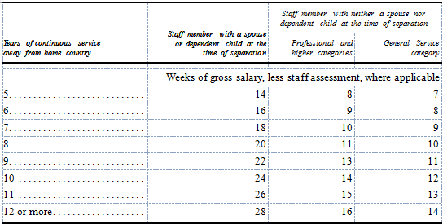

Conditions for payment

- Effective 1 July 2016, the following conditions must be met for payment of the repatriation grant:

- The Organization has the obligation to repatriate the staff member;
- The staff members has completed five years or longer of continuous and qualifying service;
- The staff member resides outside his or her home country and country of nationality, as defined by the Staff Rule, while serving at the last duty station;
- The staff member has not been dismissed or separated from service for abandonment of post.

- The repatriation grant shall not be payable to:

- Locally recruited staff members, including staff members in the General Service and related categories on assignment to a field mission as they are considered local recruits at their parent duty station;
- Staff members who have permanent residence status in the country of the last duty station at the time of separation.

- Payment of the repatriation grant is subject to the staff member providing evidence of relocation indicating that he/she has permanently relocated to a location that is outside the country of the last duty station following separation from the Organisation.

- In accordance with Staff Rule 3.19 (j), payment of the repatriation grant will cease if no claim is received within two years from the effective date of separation. However, when both husband and wife are employed by the Organization and the spouse who separates first is entitled to repatriation grant, the claim for payment of the grant by that spouse shall be considered receivable if made within two years of the date of separation of the other spouse.

Transitional measure

- As a transitional measure, eligible staff members on board as of 30 June 2016 retain eligibility to the repatriation grant schedule in effect up to the number of years of expatriate service accrued as of that date.

- In line with the transitional measure, staff members on board prior to 1 July 2016 and who subsequently separate from service prior to attaining 5 years of continuous service shall be eligible for payment of repatriation grant based on the number of years of qualifying service accrued as of 30 June 2016 and based on the schedule of payments as reflected in Annex IV of the Staff Regulations in force as of 30 June 2016 (see below table) and provided all conditions for the entitlement are met.

Annex IV to the Staff Regulations as of 30 June 2016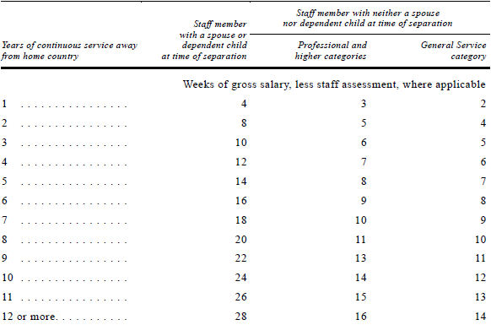

Re-employment

- Where a staff member previously paid a repatriation grant is subsequently re-employed by the Organisation and granted a fixed-term appointment with an effective date on or after 1 July 2016, upon separation from service from the subsequent appointment, any repatriation grant payable will be based on the five year eligibility requirement for the entitlement and provided that all other conditions are met, including the provisions of Staff Rule 4.17 (c).

Staff members holding temporary appointments

- Where a staff member is employed on a temporary appointment on or after 1 July 2016 and the appointment is exceptionally extended beyond 364 days for a continuous period of one year or longer he/she remains ineligible for payment of the repatriation grant upon separation from the temporary appointment.

- A staff member who is employed under a temporary appointment with entry on duty (EOD) on or after 1 July 2016 who is subsequently granted a fixed-term appointment may be eligible for payment of the repatriation grant upon separation from the fixed-term appointment provided that all conditions for the entitlement are met. Only the period of service under the fixed-term appointment will be considered for eligibility for purposes of the repatriation grant upon separation from service.

Staff from the United Nations Common System

- Where a staff member is on secondment or transferred from a UNCS Organisation prior to 1 July 2016, he/she shall retain the entitlement to repatriation grant similar to that for Secretariat staff members as per above paragraphs. Where a staff member transfers from a UNCS Organisation under the inter-agency agreement prior to 1 July 2016 and he/she separates from the Secretariat with less than five years of continuous service the repatriation grant upon separation shall be based on the number of years and months of service accrued as of 30 June 2016 in both the releasing and receiving Organisations.

- Home leave

- Effective 1 July 2016, accelerated home leave travel is discontinued in C, D and E duty stations but retained in D and E duty stations that do not fall under the rest and recuperation framework.

- Effective 1 July 2016, eligible staff members in C, D and E duty stations where accelerated home leave has been discontinued retain points accrued as of 30 June 2016 and will start accruing home leave points applicable to duty stations with a 24 month home leave cycle effective 1 July 2016 i.e. 1 service credit point per completed month. Staff serving in these duty stations will be eligible for home leave upon accruing 24 service credit points, provided all other conditions of home leave are met.

- Upon the change of duty station from a 12 to a 24 month home leave cycle, a staff member may avail of home leave provided that he/she has accrued 24 service credit points and that all conditions for the entitlement are met as per Staff Rule 5.2 and the administrative instruction on home leave and official travel, including the six months expected duration of service upon return from home leave. Upon return from such approved home leave, the next home leave will be based on the 24 month home leave schedule.

Change of home leave cycle

- The accelerated home leave in D and E duty stations may be discontinued upon approval of the duty station for rest and recuperation or upon change of the hardship classification to hardship rating of C, B or A. Similarly, the accelerated home leave may be introduced where the hardship classification changes to D or E and the duty station is not approved for rest and recuperation. In such cases, service credit point shall accrue at the applicable rate as from the effective date of change of the home leave cycle at the duty station.

Relocation package

- Effective 1 July 2016, a new relocation package is being introduced. It consists of a settling-in grant, relocation travel of the staff member and eligible family members where applicable, that will continue to be arranged by the Organisation and relocation shipment of household goods.

- Settling-in grant

- Effective 1 July 2016, staff members in the professional and higher categories and in the field service category and internationally recruited general service staff holding an appointment other than a temporary appointment and who have been authorised to travel by the United Nations to take up an appointment/assignment/transfer/reassignment of one year or longer may be eligible for payment of a settling-in grant. The purpose of the settling-in grant is to cover the initial costs of relocation. The settling-in grant replaces the assignment grant which will be payable until 30 June 2016 COB.

- Similar to the assignment grant, the settling-in grant shall be payable when a staff member has been authorised to travel for purposes of taking up an appointment/assignment/transfer/reassignment that involves relocation from beyond commuting distance from the duty station and necessitating a change of residence.

- The settling-in grant consists of two components payable to a staff member holding a fixed-term, continuing or permanent appointment and assigned to a new duty station for a period of one year or longer: 30 days daily subsistence allowance (DSA) at the rate applicable to the duty station and a lump-sum payment of one month net base salary plus post adjustment applicable to the duty station of assignment. Different from the assignment grant, the lump-sum portion of the settling-in grant is also payable to staff members at H duty stations who opt for relocation shipment for full removal of personal effects.

- A staff member holding a fixed-term, continuing or permanent appointment and assigned to a new duty station on or after 1 July 2016 for a period of less than one year shall be administered as per the provisions of the Administrative Instruction on Settling-in grant. A staff member holding a temporary appointment who has been authorised to travel by the United Nations to take up an appointment, may be paid a settling-in grant consisting of 30 days DSA applicable to the duty station only in respect of himself/herself. The settling-in grant is not payable in respect of eligible family members of staff members holding a temporary appointment irrespective of the duration of the appointment or whether the staff member is appointed to serve in a family duty station.

- As part of the settling-in grant, 30 days DSA at half the applicable rate may be paid to the staff member in respect of each eligible family member recognised by the United Nations at the time of the appointment/assignment/transfer/reassignment and travelled to the duty station at United Nations expense for the purpose of accompanying the staff member on the appointment/assignment. The settling-in grant is not payable to family members of staff members appointed/assigned to non-family duty stations as the United Nations does not travel eligible family members to non-family duty stations.

- The settling-in grant shall be administered as per the provisions of ST/AI/2016/5 or as amended with the exception of the measures indicated in the paragraphs below.

Second lump-sum of assignment grant

- Effective 1 July 2016, the second month lump-sum of the previous assignment grant is discontinued. Staff members appointed/assigned/transferred/reassigned to a new A to E duty station on or after 1 July 2016 are not entitled to payment of a second month lump sum payment.

Special measure for second month lump-sum of assignment grant

- Eligible staff members holding an appointment other than a temporary appointment appointed/assigned/transferred/reassigned to an A to E duty station prior to 1 July 2016, and who are expected to serve three years or longer at the A to E duty station may be paid a second month lump-sum of the assignment grant provided that there was a legal expectation to the second month lump-sum and that all conditions for the payment are met. Where there is an expectation that the staff member will serve more than three years in the duty station but the period is shortened, a pro-rated lump-sum may be payable. The pro-rated lump-sum shall be in the proportion that the period of service in the third year of assignment bears to twelve months. Where the reduction in service in the duty station is at the Organisation’s initiative e.g. closure or restructuring of the mission or reasons beyond the control of the staff member, or for compelling reasons such as health, a waiver of the payment may exceptionally be granted. Such exceptional requests may only be granted by the ASG, OHRM. Consequently, such requests should be submitted to the responsible office (e.g. FPD/DFS, OCHA, OAHs, Regional Commissions) for review and submission to OHRM for consideration. Upon reassignment to a new A to E duty station on or after 1 July 2016, the second month lump sum payment will no longer be payable irrespective of the expected duration of service in the new duty station.

- Payment of the second month lump-sum shall be on the basis of the staff member’s net base salary plus post adjustment applicable to the duty station of appointment or assignment at the time that the payment is due. The transitional allowance, single parent allowance and spouse allowance are not included in the calculation of the lump-sum portion of the settling-in grant payable on or after 1 January 2017.

- A staff member on temporary assignment involving a change in official duty station (staff rule 4.8), including assignments greater than or less than one year, may be eligible for an assignment/settling-in grant.

- Upon return to the parent duty station before 1 July 2016 following a temporary assignment involving a change in official duty station, the staff member may be eligible for an assignment grant (prorated as applicable). The staff member may be eligible for the second month lump-sum at an A to E duty station, provided there is an expectation that the staff member will serve more than three years at the duty station. The count towards the three years starts anew upon the staff member’s return to the parent duty station.

- Upon return to the parent duty station on or after 1 July 2016, the staff member shall not be eligible for the second month lump-sum.

- Relocation shipment

- Staff members in the professional and higher categories and field service category and internationally recruited general service staff appointed/assigned/transferred/reassigned to a new duty station or who separate from service and hold an appointment other than a temporary appointment and for whom the Organisation has an obligation to travel may be entitled to shipment of personal effects and household goods to or from the duty station of appointment/assignment. For staff members with an assignment/appointment that is expected to be of a period of two years or longer he/she may be provided with full removal of household goods if the assignment/appointment is to a duty station classified as H. Under the relocation shipment, the staff member is entitled to shipment up to a standard 20 foot container for a single staff or standard 40 foot container for a staff member with dependents. In lieu of the relocation shipment, one of the following lump-sum options may be made available to the staff member:

- $10,000 single rate;
- $15,000 family rate.

- Staff members in the professional and higher categories and field service category and internationally recruited general service staff appointed/assigned/transferred/reassigned to a new duty station for a period of less than two years or upon separation from such a duty station and hold an appointment other than a temporary appointment and who have been travelled at UN expense to the new duty station may be entitled to unaccompanied shipment of personal effects and household goods as follows:

- Up to 1,000 kgs for the staff member;
- Up to 500 kgs for the first eligible family member;
- Up to 300 kgs for each eligible family member.

- In the lieu of the unaccompanied shipment of personal effects and household goods, the staff member may opt for a lump-sum as per below:

  - $10,000 single rate;
  - $15,000 family rate.

- Staff members in the professional and higher categories and field service and category and internationally recruited general service staff appointed/assigned/transferred/reassigned to a new duty station for a period of less than one year and hold an appointment, including a temporary appointment travelled to a new duty station at UN expense may be entitled to unaccompanied shipment of personal effects and household goods to or from the duty station. The staff member will be entitled to a maximum of 100 kgs for which he or she may opt for a lump-sum of $1,200.

- Where in connection with an assignment of less than one year to a family duty station, eligible family members of a staff member holding an appointment other than a temporary appointment have been travelled in line with SR 7.2 (d) (iii) on change of official duty station, the staff member in respect of eligible family members travelled at UN expense to the new duty station, may be entitled to unaccompanied shipment of personal effects and household goods of a maximum of 100 kgs per eligible family member, provided the staff members services at the new duty station are expected to continue for a further period of six months beyond the proposed date of arrival of the personal effects and household goods. In lieu of the shipping entitlement the staff member may opt for a lump-sum of $1,200 per eligible family member. No relocation shipment shall be available for eligible family members of staff members holding temporary appointments irrespective of the duration of the temporary appointment.

- The lump-sum shall be administered in line with the provisions on relocation grant reflected in ST/AI/2015/1 [replaced by ST/AI/2016/4] or as may be amended. The lump-sum shall not be available for movements within the country and within-mission transfers involving a change of duty station even when it involves relocation to a different country, including for assignments of less than one year. In line with SR 7.2 (c), the Organisation shall not pay for the travel of eligible family members to duty stations designated as non-family. As a consequence, the Organisation shall not provide a shipment entitlement to eligible family members for travel to a non-family duty station. In the case of transfer/reassignment/assignment of a staff member from a non-family to a family duty station and vice-versa, the shipment entitlement shall be administered in line with the provisions of ST/AI/2015/1 [replaced by ST/AI/2016/4] or as may be amended.

- The above provisions relating to relocation shipment, including the lump-sum amounts shall be in force until further notice or superseded by a revision to the administrative issuance on excess baggage, shipments and insurance or other duly promulgated issuance.

Approved by: ASG, OHRM

Date: 10 January 2017

