UNITED

NATIONS ST

Secretariat
ST/AI/234/Rev.1
22 March 1989

(Amended to incorporate ST/AI/234/Rev.1/Amend.1 and Amend.2 and ST/SGB/2015/1)

ADMINISTRATIVE INSTRUCTION

To: Members of the staff

From: The Under-Secretary-General for Administration and Management

Subject: ADMINISTRATION OF THE STAFF REGULATIONS AND STAFF RULES

1. This revised instruction sets out the authority required for decisions in the administration of the staff regulations and staff rules 101.1 to 112.7. Its purpose is to clarify, amplify and bring up to date the delegation of authority on the subject in accordance with the principles set forth in Secretary-General's bulletin ST/SGB/151. This instruction is effective immediately and supersedes administrative instruction ST/AI/234 and Amend.l and 2, and those amendments indicated in paragraphs 6 and 7 of personnel directive PD/1/77.

Definitions

2. Where it is mandatory under the terms of a staff rule that a specific action will be taken when particular conditions are fulfilled, the decision to take the action will be termed a "direct application" of the rule. Where a staff rule allows the discretion to take or not to take an action within the terms and conditions laid down in the rule and with respect to the particular circumstances of the case, the decision to take the action will be termed a "discretionary decision".

3. An "exception" to a staff rule is required when a decision to take a specific action under the rule can only be authorized if a particular condition laid down in the rule is waived. Under staff rule 112.2 [currently sr 12.3], an exception to the staff rules may be made by the Secretary-General, provided that such exception is not inconsistent with any staff regulation or other decision of the General Assembly and provided further that it is agreed to by the staff member directly affected and is, in the opinion of the Secretary-General, not prejudicial to the interests of any other staff member or group of staff members. Where a rule in itself allows an action to be taken under exceptional circumstances, the decision to take the action, when the exceptional circumstances arise, is a discretionary one and does not constitute an exception under staff rule 112.2 [currently sr 12.3].
ST/AI/234/Rev.1
Page 2

Matters reserved to the Secretary-General

4. Matters reserved to the Secretary—General are listed in annex I. All matters for the decision of the Secretary-General will be submitted to him through the Under-Secretary-General for Administration and Management, to whom the Secretary-General may delegate from time to time such authority in these matters as he deems advisable.

Matters within the authority of the Assistant Secretary-General for Human Resources Management

5. Matters within the authority of the Assistant Secretary-General for Human Resources Management are listed in annex II. The Assistant Secretary-General may delegate the exercise of this authority within and outside the Office of Human Resources Management, including to an Under-Secretary-General. Authority with respect to the matters indicated by an asterisk in annex II will be exercised by the Assistant Secretary-General for Human Resources Management in respect of staff at Headquarters and at United Nations missions and information centres and by the head of the office concerned in respect of staff at other offices away from Headquarters. Authority with respect to matters indicated by two asterisks in annex II will be exercised by the Assistant Secretary-General for Human Resources Management in consultation with the Controller. With respect to the establishment of rates of allowances and of salary scales for staff in the General Service and related categories, the authority will be exercised with due regard to any decisions that may be made by the International Civil Service Commission (ICSC) under its statute.
Matters within the authority of the Controller

6. Matters within the authority of the Controller are listed in annex III. The Controller may delegate the exercise of this authority within the Office of Programme Planning, Budget and Finance.

Matters within the authority of heads of departments or offices

7. In addition to matters that involve the direct application of staff rules, matters within the discretionary authority of heads of departments or offices are listed in annex IV. Such authority will normally be exercised on behalf of the head of department or office by the appropriate executive or administrative officer at Headquarters or by the chief of administration at offices away from Headquarters.

Matters within the authority of offices away from Headquarters

8. The heads of offices away from Headquarters will exercise authority with respect to their staff on matters listed in annexes IV and V in addition to those indicated by an asterisk in annex II. They may delegate the exercise of their authority under annexes II, IV and V to the chief of administration or other officials responsible for the administration of their staff.

/…

ST/AI/234/Rev.1
Page 3

Procedure

9. The direct application of staff rules is normally the responsibility of the executive or administrative officer of the department or office concerned. In cases involving discretionary decisions, the responsible officer has the duty to refer to his or her superior all matters of importance within the delegated authority or to seek advice of the Office of Human Resources Management in cases of doubt. All exceptions under staff rule 112.2 [currently sr 12.3] require the authorization of the Assistant Secretary-General, Office of Human Resources Management, who may delegate the exercise of this authority to other officials within that Office.

Records

10. Actions taken in direct application of staff rules or discretionary decisions that affect the status of individual staff members will be recorded by the responsible officer in the official status file of the staff member concerned. The recording will be done on the personnel action (P.5) form or other appropriate action documents, such as travel authorization (PT.8) and personnel payroll clearance (P.35) forms. Discretionary decisions taken within the delegated authority, whether favourable or unfavourable to the individual staff member, will, in addition, be recorded and filed in the official status file, giving adequate details of the staff member's request, if any, and the reasoning which formed the basis for the decision. Copies of all documents recording the actions and decisions will be forwarded to the appropriate Personnel Officer, Staff Administration and Monitoring Service, Office of Human Resources Management.

11. All exceptions under staff rule 112.2 [currently sr 12.3] will be logged in a record maintained by the Staff Administration and Monitoring Service, Office of Human Resources Management, and kept available for audit purposes.

Monitoring

12. The Office of Human Resources Management has the responsibility for monitoring the direct application of staff regulations and rules and the exercise of discretion within the delegated authority. For that purpose, it will examine copies of P.5 actions and other documents recording discretionary decisions. It will bring to the attention of the head of the department or office concerned any actions or decisions that are not in accordance with the staff regulations and rules or not in conformity with established policies of the Organization and may require the department or office to correct or revoke them.

13. Interpretation of the staff rules lies within the responsibility of the Office of Human Resources Management. Staff members with inquiries with regard to the application of staff regulations or rules in their own cases should address them, in the first instance, to their executive or administrative officer. Departments or offices should address their inquiries with regard to the interpretation of staff rules and their application to individual cases to the Staff Administration and Training Division, Office of Human Resources Management.
/…

ST/AI/234/Rev.l
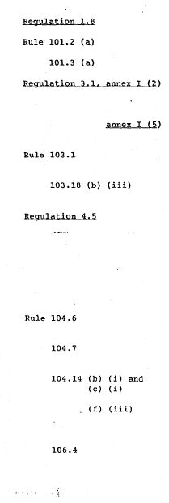
Page 4

Annex I
[Annex I is replaced by Annex I of ST/SGB/2015/1 issued on 9 April 2015]

MATTERS RESERVED TO THE SECRETARY-GENERAL

Decision to waive privilege or immunity

Establishment of normal working hours at Headquarters

Establishment of official holidays at Headquarters

Authority to make additional payments to
Under—Secretaries-General and Assistant
Secretaries—General

Authority to make additional payments to Directors and to heads of offices away from Headquarters

Establishment of salary scales for Field Service personnel

Authorization of deductions for indebtedness to third parties to which the staff member does not agree

Appointment of Under-Secretaries-General and Assistant Secretaries—General

Appointment for one year or more of staff members in the Director (D—2) level and extension of such appointments. Appointment for one year or more of staff members at the Principal Officer (D-l) level and at the Senior Officer (P-5) level in the Professional category

Establishment of conditions under which staff members shall be regarded as local recruits

Establishment of conditions governing loss of entitlement to international benefits

Appointment of members of the Appointment and Promotion Board and Committees

Promotion of staff to the Director (D-2) and principal Officer (D-1) levels and to the Senior Officer (P-5) level in the Professional category

Grant of compensation over $25,000 for death, injury or illness

/…

ST/AI/234/Rev.1
Page 5
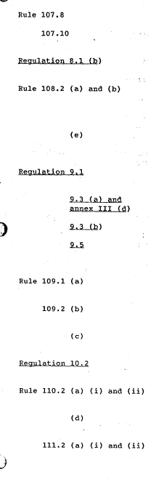

Establishment of standards of travel accommodation

Approval of exceptions to the standards of travel
accommodation

Agreement to electoral regulations drawn up by the
staff representative bodies

Selection of president, and of members representing the Secretary-General, of the Joint Advisory Committee at Headquarters and of the Secretariat-wide joint staff-
management body

Designation of secretary of Joint Advisory Committee
at Headquarters and of Secretariat-wide joint
staff-management body

Termination of appointments (except as provided in
annexes II and V)

Decision to pay indemnity to staff member dismissed
for misconduct

Decision to pay higher termination indemnity

Decision to retain in service beyond the age of 60 staff members at the Senior Officer (P—5) level and above

Appointment of chairman and members of the Special
Advisory Board

Decision to waive notice of resignation of staff at
the Assistant Secretary-General level and above

Decision to require that resignation be submitted in
person

Decision to impose disciplinary measures or to
summarily dismiss a staff member
Appointment of chairpersons and members of Joint
Disciplinary Committees

Removal of chairperson or member appointed by
Secretary-General
Appointment of chairpersons and members of Joint Appeals Boards

ST/AI/234/Rev.1

Page 6

Decision to refer appeal to a board other than
Headquarters Board or to establish an appropriate
ad hoc body

Removal of chairperson or member appointed by
Secretary—General
Decision on reports of the Joint Appeals Boards

Provisional amendments of the staff rules

Staff Rule 10.4
Decision to place a staff member at the Under-Secretary-General or Assistant Secretary-General level on administrative leave with or without pay at any time after an allegation of misconduct and pending the initiation of an investigation and until the completion of the disciplinary process. (Amended per ST/AI/234/Rev.1/Amend.2 issued on 4 Sep 2014)

/…

ST/AI/234/Rev.1
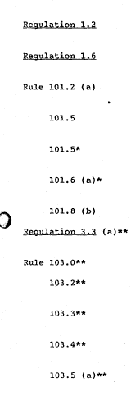
Page 7

Annex II

MATTERS WITHIN THE AUTHORITY OF THE ASSISTANT SECRETARY-GENERAL FOR HUMAN RESOURCES MANAGEMENT

Decision to assign a staff member to another department,
office or duty station

Approval of acceptance of honour, decoration, favour, gift or remuneration from any source external to the Organization

Approval of exceptions to normal working hours at Headquarters

Approval of interagency loan, secondment or transfer of
staff in the Professional category

Approval of interagency loan, secondment or transfer of
staff in the General Service and related categories
Approval of continuous or recurring outside occupation
or employment

Interpretation of staff regulation 1.7

Authorization to exempt from staff assessment the salaries and emoluments of staff engaged at local rates

Establishment of salary scales for language teachers
Establishment of salary scales for General Service staff
and related categories

Establishment of salary scales for Trades and Crafts category

Establishment of salary scales for locally recruited
mission staff

Establishment of rate and conditions of payment of
non-resident's allowance

---------------
* Authority exercised by the head of the office concerned in respect of
staff at offices away from Headquarters.

** Authority exercised by the Assistant Secretary-General for Human Resources Management, in consultation with the Controller.

/…

ST/AI/234/Rev.1
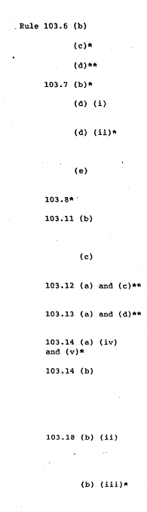
Page 8

Organization of language proficiency tests
Decision to retest language knowledge

Establishment of rates of language allowances

Application of dependency rate of post adjustment

Decision to apply post adjustment of former duty
station for more than six months

Decision to pay subsistence allowance on appointment or assignment to a new duty station for less than one year

Establishment of conditions for housing supplement to post adjustment

Decision to withhold salary increment

Granting of special post allowance (except as provided
in annex V) including special post allowance to the D-2 level

Granting of special post allowance with immediate
effect

Establishment of rates and conditions for overtime
compensation

Establishment of rates and conditions for night
differential

Granting of more than two months' salary advance on initial appointment or change of duty station

Granting of salary advance in exceptional and compelling circumstances, irrespective of the amount, with regard to
staff members at Headquarters and in the amount of more
than two months' salary with regard to staff members at
offices away from Headquarters

Authorization of deduction for indebtedness to the
United Nations which relates to actions taken under
the authority of the Assistant Secretary-General for
Human Resources Management

Authorization of deduction for indebtedness to third
parties with the agreement of the staff member

/…
ST/AI/234/Rev.1
Page 9

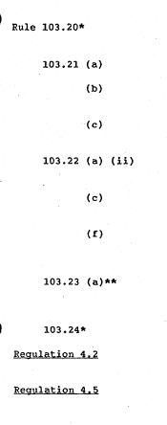

Approval of education grant, special education grant
for disabled children and related travel
Designation of special mission assignments

Establishment of rates, conditions and currency of
mission subsistence allowance

Establishment of rates and conditions for payment of
clothing allowance
Decision to pay assignment allowance on appointment
or assignment to a new duty station

Decision to pay subsistence allowance on assignment
to a duty station for less than one year

Decision to pay assignment allowance at duty station in
staff member's home country after two years' service at
duty station outside home country

Establishment of rates for dependency allowance for language teachers and General Service and related categories

Approval of dependency allowances

Decision to transfer a staff member to another
department, office or duty station

Appointment for a total period of less than one year of:
(a) staff members at the Director (D-2) level; and (b) staff members at the Principal Officer (D-l) level and in the Professional category at Headquarters

Appointment of staff members in the Professional category
up to the First Officer (P-4) level for one year or more on recommendation of the Appointment and Promotion Board

Appointment of staff members in the Field Service category

Appointment of staff members in other categories at
Headquarters

/…
ST/AI/234/Rev.1

Page 10

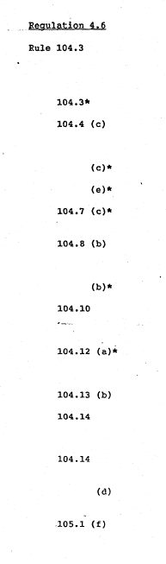

Establishment of medical standards

Decision whether to give new appointment or reinstate within
12 months of separation from service or on disability benefit
in respect of staff in the Professional category and above

Decision in respect of other staff

Decision to authorize change of residence status in respect
of staff in the Professional category and above

Decision in respect of other staff
Decision to require information from staff member

Decision whether entitlement to international benefits is lost

Decision as to which nationality a staff member is most
closely associated in respect of staff in the Professional category and above

Decision in respect of other staff

Decision to appoint candidate having any of the family relationship indicated in paragraph (a) of the rule
to a staff member
Decision to reduce probationary period or to extend
probationary period on recommendation of the appointment
and promotion body

Decision to grant regular appointments

Promotion of staff members in the Professional category
up to the First Officer (P-4) level on recommendation
of the Appointment and Promotion Board
Promotion of staff members within the purview of the
Appointment and Promotion Panel at Headquarters

Appointment of members of subsidiary panels at Headquarters

Establishment of terms and conditions of annual leave
for local mission staff

/…
ST/AI/234/Rev.1

Page 11

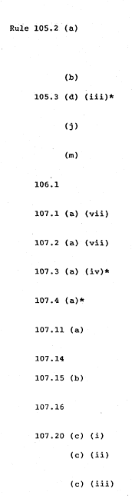
Grant of special leave with full or partial pay, other than for jury service, and grant of special leave without pay for more than three months (except as provided in annex V)

Grant of special leave for military service

Authorization to designate a country other than the
country of nationality as the home country

Approval of separate travel of dependants not in the
same home leave year

Establishment of terms and conditions for grant of
accelerated home leave

Exclusion from participation in the United Nations
Joint Staff Pension Fund
Authorization of travel of staff members for reasons
other than medical or security

Authorization of travel of eligible family members
for reasons other than medical or security
Decision that special circumstances or conditions
make family members' travel undesirable

Decision that there are compelling reasons for
authorizing payment of return travel expenses

Establishment of rates and conditions for
reimbursement of travel costs by automobile

Establishment of transit allowance
Authorization to pay higher travel subsistence
allowance

Establishment of special rates of travel subsistence
allowance

Establishment of special rates for installation grant
Establishment of conditions for extension of
time-limits for installation grant

Establishment of conditions for payment of lump-sum
installation grants

/…
ST/AI/234/Rev.1

Page 12

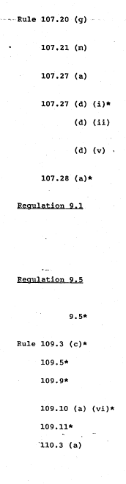

Authorization of installation grant when no travel is paid

Establishment of terms and conditions for additional
shipment entitlements

Decision whether to pay removal costs or assignment
allowance

Setting of a higher maximum

Authorization of storage costs not directly incidental to
normal transportation

Establishment of conditions for transportation of automobiles

Authorization of removal on resignation before completing two years of service

Termination of appointment for reasons of health

Termination of appointments of staff members at Headquarters within the purview of subsidiary panel on its recommendation
(in consultation with Office of Legal Affairs) other than termination of permanent appointments for unsatisfactory services

Decision to retain staff in the Professional category up to
and including the First Officer (P—4) level in service
beyond the age of 60

Decision to retain staff in the General Service and related categories in service beyond the age of 60

Decision to pay compensation in lieu of notice

Approval of repatriation grant

Decision to waive requirement of restitution of
advance annual or sick leave

Approval of death benefit

Certification of service

Agreement to waive reference to the Joint Disciplinary
Committee

/…
ST/AI/234/Rev.l

Page 13
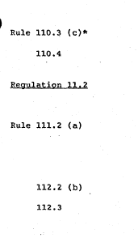

Reprimand of a staff member

10.4 Decision to place a staff member in the General Service or related categories, the Professional and higher categories up to and including the D-2 level, and the Field Service category, on administrative leave at any time after an allegation of misconduct and pending the initiation of an investigation and until the completion of the disciplinary process. Such placement on administrative leave is with pay unless otherwise determined by the Under-Secretary-General for Management.
(except as provided in annex V)(Amended per ST/AI/234/Rev.1/Amend.2 issued on 4 Sep 2014)

Agreement to direct submission of an application to the Administrative Tribunal (in consultation with Office of Legal Affairs)

Decision to seek assistance of chairperson or designated member of Joint Appeals Board in conciliation proceedings

Decision on request for review

Decision to make an exception to the rules

Decision to require staff member to reimburse United
Nations for financial loss

/…
ST/AI/234/Rev.1

Page 14
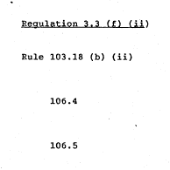
Annex III

MATTERS WITHIN THE AUTHORITY OF THE CONTROLLER

Authorization to make payments in excess of amounts
deducted as staff assessment

Authorization of deduction for indebtedness to the
United Nations which relates to actions taken under
the authority of the Controller

Grant of compensation for death, injury or illness up to $25,000 (on recommendation of Advisory Board on
Compensation Claims)

Grant of compensation for loss or damage
(on recommendation of Claims Board)

/…

ST/AI/234/Rev.1
Page 15

Annex IV

MATTERS WITHIN THE AUTHORITY OF THE HEADS OF DEPARTMENTS
OR OFFICES
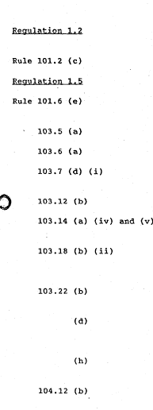

Decision to assign staff members to any activity
within the department or office

Decision to require staff member to work overtime

Authorization to disclose information

Approval of outside activity in accordance with
administrative instruction ST/AI/190/Rev.1

Approval of non-resident's allowance

Approval of language allowance

Decision to apply post adjustment of former
duty station for maximum of six months

Grant of time off to staff in Professional category
Grant of up to two months' salary advance on initial
appointment or change of duty station

Authorization of deduction for indebtedness to the United Nations which relates to actions taken under the
authority of heads of departments/offices

Decision to pay assignment allowance beyond five years
for a further period not exceeding two years

Decision to continue to pay assignment allowance at
duty station in the field on extension of appointment or assignment for less than five years

Decision to adjust payment of assignment allowance
where both husband and wife are staff members

Decision to extend the fixed-term appointment of staff
members in the Professional category and above for no more
than one month beyond the date of expiration of the
appointment approved by the Office of Human Resources
Management. Decision to extend the fixed-term appointment of other staff members for no more than three months beyond
the date of expiration of the appointment approved by the
Office of Human Resources Management.

/…
ST/AI/234/Rev.1

Page 16


Decision to require staff members to satisfy the
Medical Officer by medical examinations that they are
free from ailment likely to impair the health of others
(on advice of Medical Officer)

Decision to require staff member to undergo medical
examination and inoculation before or after mission

Decision to require staff to take leave within a
designated period

Approval of advance annual leave

Grant of special leave for jury service

Grant of special leave without pay for up to
three months

Decision on timing of first home leave
Approval of advanced home leave

Approval of delayed home leave

Decision to require home leave to be taken in conjunction
with travel on official business or on change of
official duty station

Approval of separate travel of eligible family members
within the same home leave year

Decision to require evidence of length of time
spent in home country

Approval of sick leave (on advice of Medical Officer)

Refusal of further sick leave or withdrawal of unused
portion (on advice of Medical Officer)

Decision to require a medical certificate to be submitted
or to undergo a medical examination (on advice of Medical Officer)

Approval for staff member on sick leave to leave the area
of the duty station (on advice of Medical Officer)

Approval of sick leave within period of annual leave
(on advice of Medical Officer)

/…

ST/AI/234/Rev.1
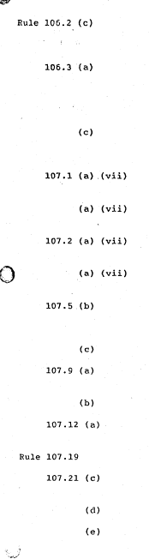
Page 17

Direction to staff member not to attend the office
because of contagious disease or quarantine order
(on advice of Medical Officer)

Approval of maternity leave (on advice of Medical
Officer, as appropriate)

Approval of return to duty (on advice of Medical
Officer, as appropriate)

Approval of sick leave for maternity cases
(on advice of Medical Officer)

Authorization of travel of staff member for medical
reasons (on advice of Medical Officer)

Authorization of travel of staff member for security
reasons (on advice of Security Co-ordinator)

Authorization of travel of eligible family members for
medical reasons (on advice of Medical Officer)

Authorization of travel of eligible family members for
security reasons (on advice of Security Co-ordinator)

Authorization of one-way travel for child on ceasing
to be a dependant or on completion of continuous
full-time attendance at university
Authorization of repatriation travel of former spouse

Approval of alternative route in best interests of the
United Nations a/

Approval of alternative mode of transportation a/

Authorization for staff member to make own
arrangements for travel a/
Authorization of miscellaneous travel expenses

Approval of baggage charges considered excess
by one Company a/

Authorization of additional excess baggage charges
Authorization of unaccompanied shipments relating to home leave etc.

/…
ST/AI/234/Rev.l

Page 18

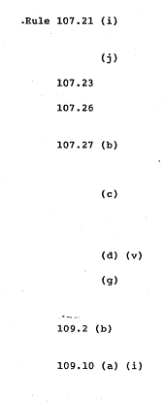

Authorization of shipments of personal effects on
travel for less than one year

Authorization of conversion of shipment to air freight

Approval of travel advances

Approval of payment of reasonable costs of
transportation of decedents
Authorization of removal costs from a place other than
the place of recruitment or the place of home leave
without an increase in cost to the Organization

Authorization of removal costs to a place other than
the place to which the staff member is entitled to
be returned on separation from service without an
increase in cost to the Organization

Authorization of transportation of automobile

Decision to pay storage charges beyond five years for
up to two further years when staff member's assignment
is extended at initiative of Organization.
Acceptance of resignation on short notice up to and
including the Director (D-2) level

Authority to grant annual leave during period
of notice of resignation

Notes

a/ In consultation with the Office of General Services or corresponding administrative unit away from Headquarters.

/…

ST/AI/234/Rev.1
Page 19

Annex V

MATTERS WITHIN THE AUTHORITY OF HEADS OF OFFICES AWAY FROM
HEADQUARTERS WITH RESPECT TO THEIR STAFF (IN ADDITION TO
THOSE LISTED WITH AN ASTERISK IN ANNEX II AND THOSE LISTED
IN ANNEX IV)
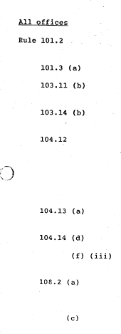

Establishment of normal working hours of office and
approval of exceptions thereto a/

Establishment of official holidays at office a/
Grant of special post allowance within the General
Service and related categories

Grant of up to two months' salary advance in
exceptional and compelling circumstances

Grant of probationary appointments to staff members within
the purview of subsidiary panel on its recommendation. Grant
of fixed-term appointments to staff in General Service and
related categories. Grant of fixed-term appointments for
total period of less than one year to staff in the Professional category and the Principal Officer (D-l) level

Grant of permanent appointments to staff members within
the purview of subsidiary panel on its recommendation

Appointment of members of subsidiary panels
Promotion of staff members within the purview of subsidiary
panel on its recommendation

Selection of president, and of members representing the
head of office, of the Joint Advisory Committee or
corresponding staff-management body at office a/

Designation of secretary of Joint Advisory Committee or
corresponding staff-management body at office

/…
ST/AI/234/Rev.1
Page 20

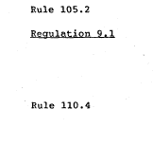
United Nations Office at Geneva. the United Nations Office at Vienna b/ and the
United Nations Environment Programme and the United Nations Centre for Human
Settlements

Grant of special leave without pay for up to one year

Termination of appointments of staff members within the purview
of subsidiary panel on its recommendation (on advice of the
Legal Liaison Officer) other than termination of permanent appointments for unsatisfactory services c/

10.4 Decision to place a staff member in the General Service or related categories, and the Professional and higher categories up to and including the D-2 level, on administrative leave at any time after an allegation of misconduct and pending the initiation of an investigation and until the completion of the disciplinary process. Such placement on administrative leave is with pay unless otherwise determined by the Under-Secretary-General for Management. (Amended per ST/AI/234/Rev.1/Amend.2 issued on 4 Sep 2014)

Notes

a/ Decisions will be reported to the Office of Human Resources Management
through copies of relevant information circulars.

b/ Except for internationally recruited staff of the International Trade
Law Branch.

c/ The Executive Director of the United Nations Environment Programme has authority to terminate permanent appointments, including for unsatisfactory services, of staff whose appointments are limited to service with the United Nations Environment Programme and whose posts are financed from the Environment Fund. (Amended per ST/AI/234/Rev.1/Amend.1 issued on 14 June 1990)

-----

