United Nations Language and Communications Programme
Advanced Conversation
Practice and perfect your English conversation skills by discussing interesting topics
Discuss a variety of topics to develop your fluency and accuracy in English |  | UN Photo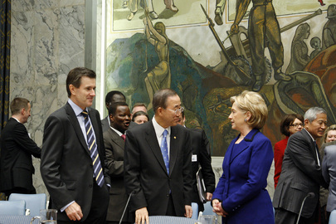UN Photo/Mark Garten

The English Language Programme
offers you the opportunity to expand your vocabulary and develop your fluency

Course Objectives:  - Understand and use a wider range of idiomatic expressions  - Speak about a variety of topics fluently and with detail  - Speak in an organized, cohesive manner  - Present a clear argument, by explaining and justifying opinions  - Summarize spoken content, and give feedback, considering different viewpoints | Target Audience:  High level learners of English who want to improve their speaking ability.  Duration:  One 1.5-hour lesson per week for 8 weeks (12 hours)  Course Schedule & Location:  LMS-2742-1  26 September-15 November  Tuesdays 6:30-8:00 pm  Computer Lab A | Eligibility:  - Level 7 or higher  - CEFR Target level = B1/B2  To Register:  - UN Staff:  Use your staff Inspira account: inspira.un.org  - Other eligible students:  Register via Elearning: elearning.un.org  - Go to Main Menu –- (Self Service) – My Learning  - Type 2742 in the  “Keyword” box  Contact:  Pen-Pen Chen  penguistics@gmail.com

