Taking Control of Your Career
UNDERSTANDING THE NEW WORLD OF WORK

Table of Contents
Part 3: Career Transitions
ACTIVITY 1: Understanding the New World of Work 3
What Does This Mean for You? 4

ACTIVITY 9: Understanding the New World of Work
Keeping up with the rapidly changing workplace is key to your career growth and success. You need to adapt to these trends or risk being “left behind.”
In this new world of work:
- Job change is becoming more common. By the time they have been working from 7 to 10 years, many people have held 3 or more jobs.
- There is a greater emphasis on core competencies, skills, and behaviours—those things which one does well which were the source of past accomplishments—rather than job titles or longevity.
- Employees need to be increasingly flexible to organizational changes and new opportunities.
- Job satisfaction starts to decline dramatically after about five years in the same position.
- Performance-based, shorter-duration, renewable contracts are replacing traditional lifetime employment and loyalty.
- The location of work is changing. More teams are global and virtual.
- The increased complexity of work requires more and better collaboration and communication. Technology skills are vital.
- The workplace focuses less on “jobs” per se and more on roles and job profiles. People are assigned to projects and assignments based on their capabilities not just titles.
- Successfully moving from assignment to assignment increasingly depends on maintaining multiple networks and developing work search skills.
- Knowledge work is increasing on all fronts.

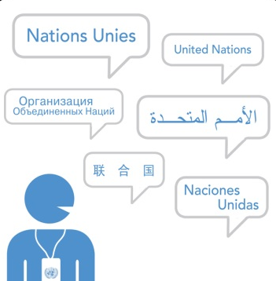
The United Nations is not immune to these general trends. Specifically, there is an:
- Increased focus on managing your own career and career mobility
- A shift from permanent toward continuing contracts
- Introduction of the Young Professional Programme
- Greater movement between Headquarters and field locations
- More emphasis on career mobility

What Does This Mean for You?
To survive and excel in the new workplace, you need to:
- Make a life-long commitment to continuous personal growth.
- Develop your competitive advantage, in other words, what makes you so special?
- Assume the responsibility of being the principal driver of your career, with support from your manager and the Organization.
- “Go with the flow” so you can quickly and nimbly adapt in times of uncertainty and rapid change.
- Weigh career opportunities based on which ones offer the most learning potential.
- Be prepared to take on new responsibilities on a trial basis.
- Pay attention to expanding and improving your transferable skills, that is, those skills and experiences which are useful for a wide range of jobs.
- Have an ongoing focus on building professional relationships and expanding your network.
Instructions: Answer the following questions. You can enter as much text as you want.

- What are the implications of the new world of work for your career planning and competency development?
Your response
- Are there other trends which you think are important?
Your response
- How can you prepare yourself for changes in the new world of work?
Your response
- What support do you need and from whom?
Your response

Adapted from Job Shift by William Bridges, 1994.
See ST/SGB/2011/9: Continuing Appointments (http://www.un.org/ga/search/view_doc.asp?symbol=ST/SGB/2011/9) and ST/AI/2012/3: Administration of Continuing Appointments (http://www.un.org/ga/search/view_doc.asp?symbol=ST/AI/2012/3) .
See ST/SGB/2011/10: Young Professionals Programme (http://daccess-dds-ny.un.org/doc/UNDOC/GEN/N11/556/20/PDF/N1155620.pdf?OpenElement).

