Taking Control of Your Career
INGREDIENTS FOR AN ACTION PLAN

Table of Contents

Part 1: Career Planning
ACTIVITY 2: Ingredients for an Action Plan 3
Looking for Opportunities 4
All Posts in the UN Secretariat 4
Temporary Job Openings (TJOs) 7
International Civil Service Commission (ICSC) Openings 9
Generic Job Profiles 10
Reach Out to Your Connections 13
Options for an Action Plan 14
Getting from Where I Am to Where I Want to Be 16
Getting Support for Your Plan 18

ACTIVITY 2: Ingredients for an Action Plan
Activity 1 focused on personal assessment. This included:
- Reviewing your current development needs
- Thinking about the professional goals you want to achieve in the
next 5 years
- Identifying competencies, skills, and knowledge you need to
reach these goals
- Taking stock of your major strengths, values, and skill preferences
- Determining what motivates you at work
Now, take some time to review the entries you’ve made up to this point in this workbook to see whether there are any important omissions or gaps. This reflection will help you shape a short-term personal career plan as you work through the rest of “Taking Control of Your Career.”
Note: This might also be a good time to contact the Career Resource Centre Team by phone at +1 212 963 9500 or by email at centrec@un.org to schedule an in-person or Skype session with a career counsellor. When you finish the next section of this module, you may send it to the counsellor via email so he or she may review it prior to your meeting.

Looking for Opportunities
Part of your career advancement plan should include regular searching for new employment opportunities. It’s up to you to take the initiative to look for jobs which are well aligned with your goals.
Depending on the type of job you are seeking, you can look on Inspira, iSeek, or the ICSC web site. The following explains how to find openings on each of these systems.

All Posts in the UN Secretariat
  - Go to https://careers.un.org.

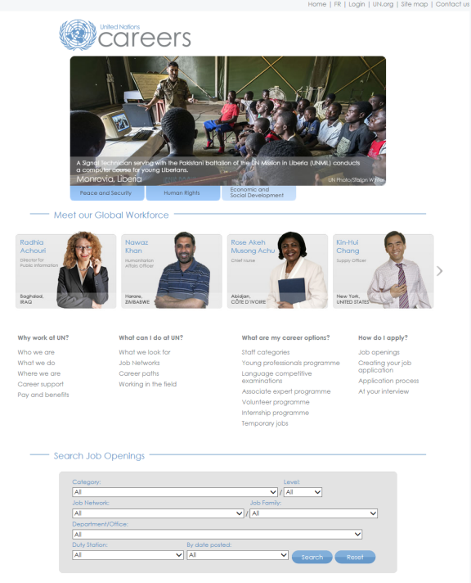

  - Enter search criteria by clicking the arrows to make selections.
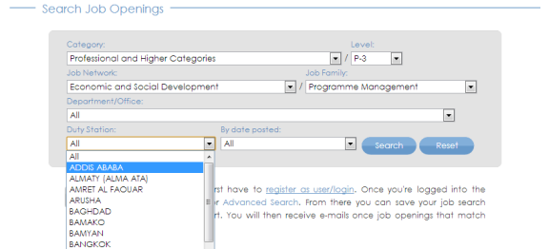
  - Click Search to view the results.

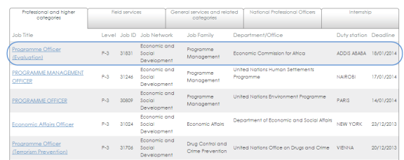

  - Click a job title of interest to view its description.
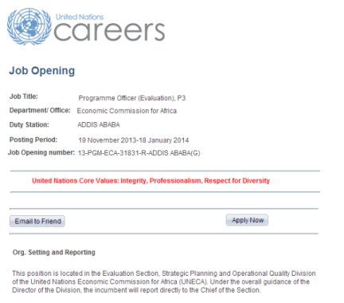

Set Up Inspira Job Alerts
You can set up an alert so you will receive an email whenever there’s a job opening in Inspira which matches your search criteria. To do so:
  - Log in to Inspira.
  - Enter or select your search criteria.

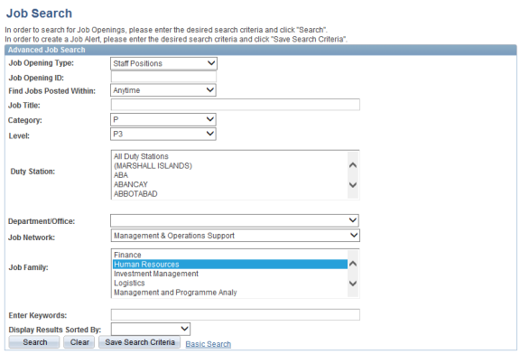

  - Click Save Search Criteria.
  - Give your search a name and enter your email address.

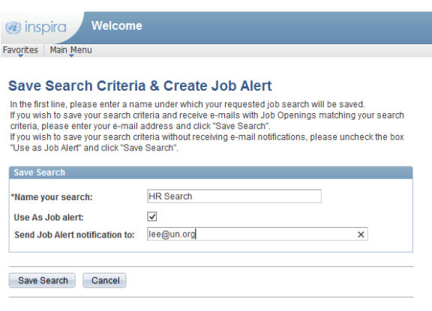

  - Click Save Search.
Temporary Job Openings (TJOs)
To look for TJOs at the UN Secretariat and Offices Away from Headquarters (OAHs):
- Go to https://iseek-newyork.un.org/tjo
- On the iSeek home page, click Temporary Job Openings under QuickLinks.
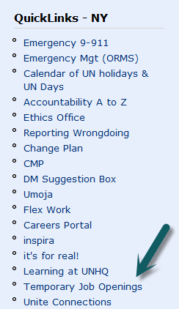
Alternatively, click Topics > HR > Careers, Staffing and Learning > Temporary Job Openings.
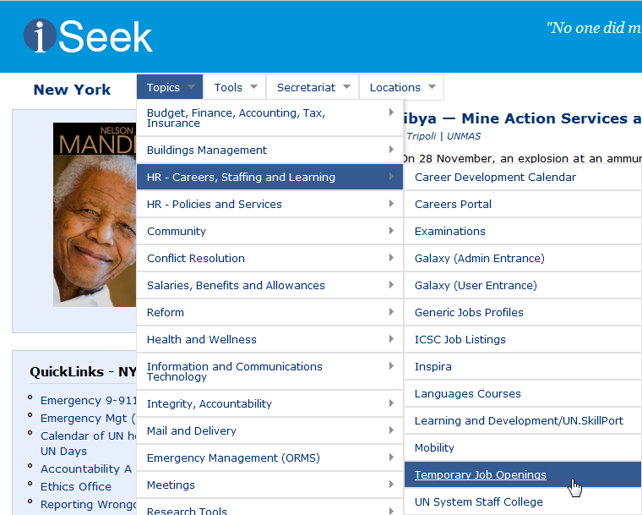

- Click the links on the left side of the Temporary Job Openings page to see current openings in your area of interest.
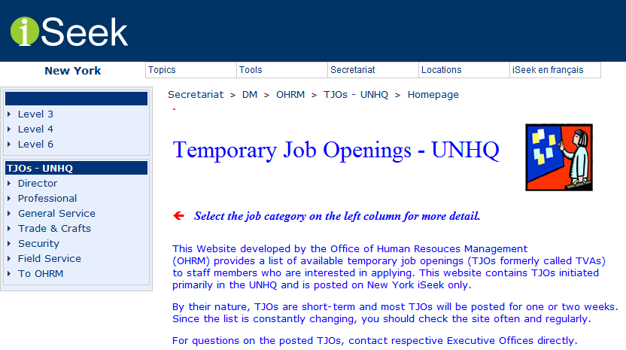
International Civil Service Commission (ICSC) Openings
To view all vacancies in the entire UN System:
- Go to http://jobs.unicsc.org/.
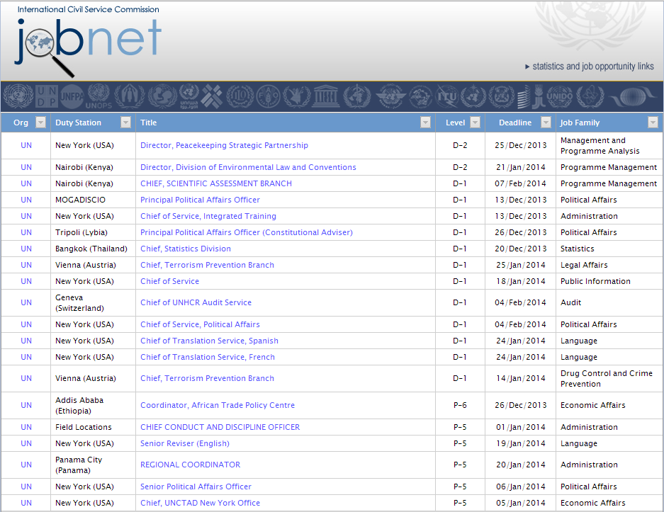
- Click the arrow above any column to filter the search results on additional criteria:
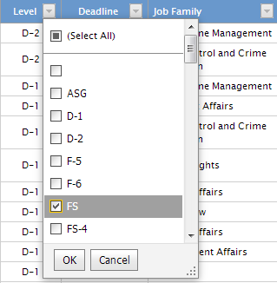

Generic Job Profiles
Generic Job Profiles provide an overview of the different types of positions available in the UN system. Each profile includes a statement of duties and responsibilities as well as a list of competencies required for the position. These profiles serve as a point of reference to help you determine whether you are prepared for such a position and, if not, the competencies you need to acquire to be considered as an applicant.
To view Generic Job Profiles:
- Go to https://iseek2.un.org//webpgdept809_7
- Click the occupational group of interest to you.

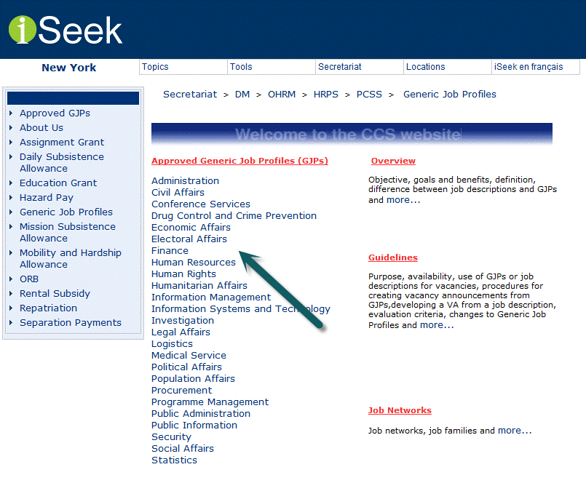

- Click the specific job, category, and level of interest to you.
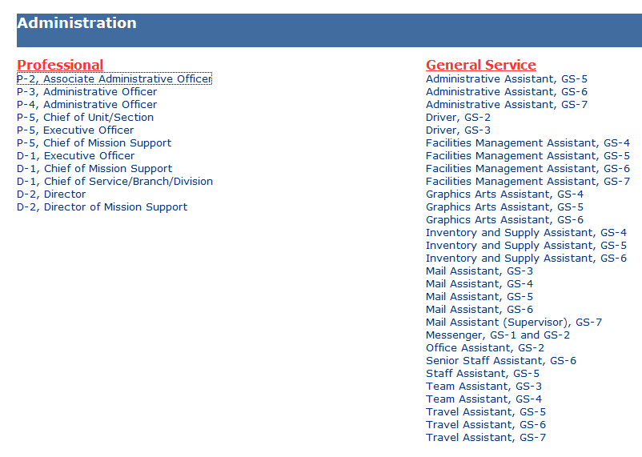
- Review the detailed Generic Job Profile.
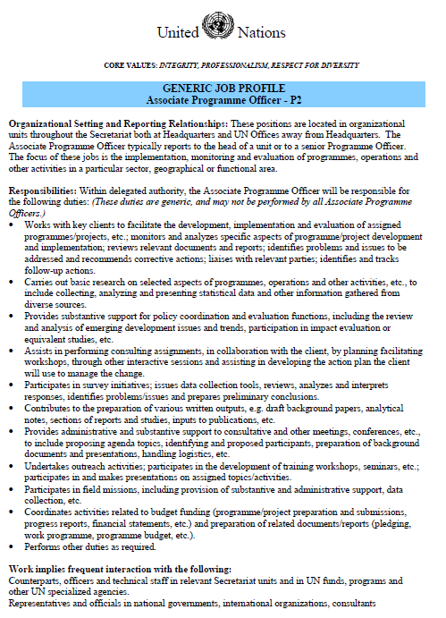
Reach Out to Your Connections
Have you connected to key people in your network to share your career interests and get information about possible job opportunities?
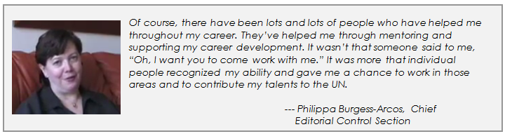
Instructions: Enter the names of people in your network who might be helpful in your effort to advance or change your career path. You can type as many names as you want in each category.
Note: A “Super Connector” is a person who has many connections. He or she usually knows many more people than average. For example, a Super Connector’s network might include senior colleagues, fundraisers, people in public relations, media personnel, and the like.
Who are some of your important connections?
Friends: | Names
Mentors: | Names
Super Connectors: | Names
People outside your friendship circle: | Names
Managers: | Names
Note: Activity 7, “Building Career Connections,” covers networking in more detail.

Options for an Action Plan
In addition to regularly scanning for opportunities and networking with your contacts, there are many other options you might consider including in your career action plan, some of which are listed below.
Instructions: Select each option which you want to include in your action plan. You can check as many options as you want. You can also add options which don’t appear on this list by checking “Other” and entering them in the box below it.
Which of the following options might be possible to include in your action plan?
Return to school for a higher degree or professional certificate | ☐
Participate in a UN or outside training to upgrade substantive skills | ☐
Take a sabbatical or Special Leave Without Pay (SLWP) | ☐
Take the YPP exam (if eligible) | ☐
Research mobility options (for example, undertaking peacekeeping or electoral mission assignments, moving to a new function, or making a lateral move to a new position) | ☐
Seek out mentoring/coaching support | ☐
Volunteer for a special assignment (for example, a task force, committee, project  or covering for a colleague ) | ☐
Work short rotations in other units to get experience performing new functions | ☐
Update your PHP and cover letter | ☐

Regularly apply for vacant posts | ☐
Experiment with a new type of work without making a long-term commitment (such as by volunteering or by accepting a short assignment in a different capacity) | ☐
Enter any additional options you want to include in your action plan.

Getting from Where I Am to Where I Want to Be
Create a personal career plan for the next 6 months based on your self-assessments and the ideas presented so far in this workbook. First, identify up to three career-related goals you want to accomplish in the coming months. Then, list up to five steps you plan to take to reach those goals.
Use the SMART paradigm as a guide when setting your goals. SMART goals are:
Specific
Measurable
Achievable
Realistic
Time-sensitive
Include as much detail as you can about what you want to achieve, how you want to achieve it, how you’ll know when you’ve achieved it, and by when you want to achieve it.
Instructions: Enter your goals and action steps in boxes below. You can type as much as you want in each box.
- Within the next six months, I will accomplish these career-related goals:
Goal
Goal
Goal
Goal
Goal
Goal

- To accomplish these goals, I will:
Action
Action
Action
Action
Action
Action

Getting Support for Your Plan
Most people need help creating and implementing their career plan. You may seek and get such support by having extensive discussions with a manager, mentor, career counsellor, or trusted peer. This dialogue may provide you with different perspectives on your goals, other strategies for achieving them, resources (such as finances) to enable these activities, and ongoing feedback on your progress.
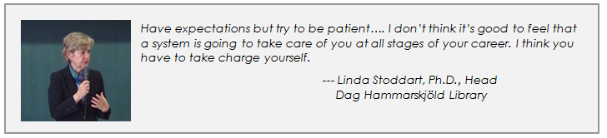
Instructions: Type your answers below. You can enter as much text as you want.

- Who will you seek out for feedback on your plan?
Your response
- Who can you ask to support you in implementing your plan?
Your response

For general information about the Young Professionals Programme, see https://careers.un.org/lbw/home.aspx?viewtype=NCE&lang=en-US. To find out whether you are eligible for and how to apply to YPP, see https://careers.un.org/lbw/home.aspx?viewtype=NCEA.
For help preparing your PHP and cover letter, please enrol in the self-paced activity "Creating Your Job Application/Profile" accessible through Inspira(“Learning Catalogue” >”Browse Catalog” > “Working for the UN” > “Career Guidance” >Career Resource Centre Workshops”.

