TAKING CONTROL OF YOUR
CAREER
KNOWING YOURSELF AND WHAT YOU WANT

Table of Contents

Part 1: Career Planning
ACTIVITY 1: Knowing Yourself and What You Want 3
Reflections on Your Career 3
Thinking Ahead 5
Personal Assessment 7
Personality Type Inventory 8

ACTIVITY 1: Knowing Yourself and What You Want

This activity will help you identify your values, occupational interests, strengths and achievements, skills, and preferences. It will also help managers discuss professional development and career aspirations with their staff.
Looking back on your career is the first step in moving forward. It is useful to think about what actions have positively influenced your career so far and whether the same or similar actions might help your career progress
even further.
Reflections on Your Career
Instructions: Answer the following questions. You can enter as much text as you want. At the end of this activity, you may want to send this document to a coach on the Career Coaching Team and arrange a meeting to discuss your reflections.

- What experiences or actions that you have initiated previously have positively affected your career? How did you initiate them?
What experience or action  positively affected your career? | How did you initiate it?
Your response | Your response
Your response | Your response
Your response | Your response
Your response | Your response
Your response | Your response

- What types of organizational support has helped your career growth?
Your response
3. Who helped you make cross-functional, interagency, or other job transitions?
Your response
- If you have changed duty station and function what helped you in the past ?
Your response
5. Did anyone make the transition easier for your spouse and children?
Your response

Thinking Ahead
An important part of your career planning process is visualizing where you want to be in the short-and long-term future. What would you like to be doing and where? What skills and knowledge do you need to get there? Your answers to these questions will help you clarify your career goals and develop an action plan to achieve them.
Instructions: Type your answers in the tables below. You can enter as much text as you want.
1. What job assignment(s) would you like to have or career move(s) would you like to make in the coming years? Why?
Timeframe | Job Assignment/Career Move | Why?
1 – 2 years
 | Your response | Your response
3 – 5 years
 | Your response | Your response

- What skills and knowledge do you need to develop to be eligible for these assignments and career moves?
Timeframe | Job Assignment/Career Move | Skills and Knowledge Needed
1 – 2 years
 | Your response | Your response
3 – 5 years
 | Your response | Your response

- Who might help you gain the experience you need to get your desired job(s)?
Timeframe | Job Assignment/Career Move | Who can help?
1 – 2 years
 | Your response | Your response
3 – 5 years
 | Your response | Your response

4. How are you going to prepare for your desired new job assignment(s)?

Timeframe | Job Assignment/Career Move | Preparations
1 – 2 years
 | Your response | Your response
3 – 5 years
 | Your response | Your response

Personal Assessment
Knowing what you do well in the workplace can serve as a springboard for professional development. Your work preferences and personal motivators also influence where you want to go in your career and how you want to get there.
Instructions: Type your answers below. You can enter as much text as you want.

- What do you do well? What are your strengths? What specific skills do you have that you could use in other positions?
Your response
- What is unique about your work experience?
Your response
- What are your work preferences?
- Do you like to work alone or with others?
- Do you like having a job with a lot or little structure?
- Do you prefer assignments that are very specific or that give you a lot of room for imagination?
- Would you prefer to work in HQ or a field location?
Your response
- In what areas would you like to continue your professional growth and learning?
Your response
- What values drive or motivate you (for example, achievement, creativity, making a difference, money, or service)?
Your response

Personality Type Inventory
The Myers-Briggs Type Indicator (MBTI) is the most widely used personality inventory in the career development field. By asking you to identify your preferences, the MBTI can help you determine and learn about your personality type. The MBTI can also help you find your strengths, recognize possible blind spots, and get your ideas across more effectively to co-workers and your boss.
In this activity, you take a modified version of the MBTI.

Instructions: Follow the steps below. In step 4, be sure to make a selection in each drop-down list. Make sure you have at least 10 – 15 minutes to complete the questions. Do your best to answer the questions honestly, even if you do not like the answer.

- Enter the following address in your browser: http://www.16personalities.com/free-personality-test.
- Answer each of the questions by “dragging”⁶ the circle in the middle of the bar in one direction or another. There are six positions on the bar, three to the left and three to the right, as shown here:
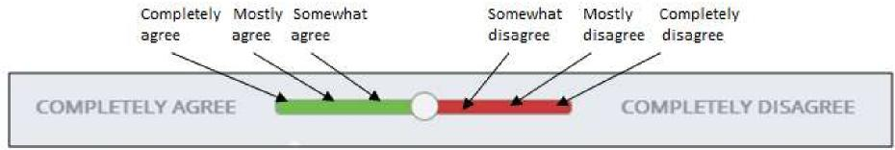
Note: Be sure to move each circle in one direction or the other; at the end of the activity, none of the circles should be exactly in the middle of the bar.
- When you have answered all the questions, click Results at the bottom of the page.
- At the top of the Results page, a 4-letter code appears after “Your personality type:” Enter the code which appears by selecting a letter from each of these lists:
Select a letter. Select a letter. Select a letter. Select a letter.
- Click Learn More About Your Type and review the detailed description of your personality type.
6 To drag the circle, point to it with your mouse, click and hold down your mouse button, move the circle to the appropriate position, and then let go of the mouse button.

6. If you see a diagram at the bottom of the description page which looks like this one:
- Click Careers to read about the types of jobs for which you are most suited.
- Click Workplace to learn more about how you’re likely to function in the work environment depending on whether you are another staff person’s colleague, manager, or subordinate.
If, instead, you see a chart at the bottom of the description page like the one shown here:
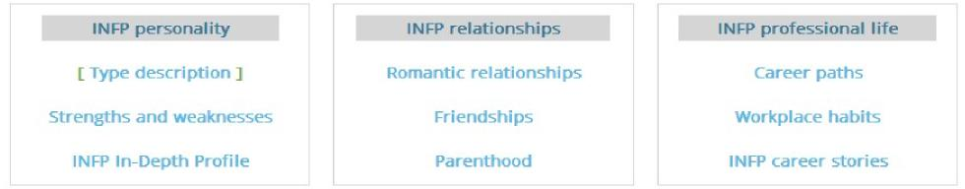
- Click Career paths to read about the types of jobs for which you are most suited.
- Click Workplace habits to learn more about how you’re likely to function in the work environment depending on whether you are another staff person’s colleague, manager, or subordinate.
What Do You Think?
Instructions: Enter your thoughts about the personality type you were assigned and the descriptions provided in the assessment tool. You can enter as much text as you want.

- Does the personality type match how you think about yourself? What resonates with you? What doesn’t?
Your response
- Did any of the information surprise you? If so, what?
Your response
- Now that you know your type, how do you think it affects your job performance?
Your response
- Does the information provided give you any new ideas about the types of positions or work environments you might prefer? If so, what are they?
Your response

To plan a coaching session email uncareercoaching@gmail.com. Find more information here.

