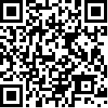

Information circular*

* The present circular is in effect until further notice.

To: Members of the staff

From: The Under-Secretary-General for Management

Subject: Membership of the Joint Harassment Prevention Boards

1. The purpose of the present circular is to inform the staff of the appointment of Mr. Lars Larson (management nominee), United Nations Office at Vienna, to the Joint Harassment Prevention Board in Vienna, for a term of two years, effective 25 January 2013. He replaced Mr. Michael Nickovich, who retired on 31 December 2012.
2. This information circular accordingly amends ST/IC/2011/26.

