Activity Guide 5- HR Partner Approval and Pushback

AS HR Partner

Step | Step Description
 | When the SRO submits the Application to HR Partner, HR Partner will receive an email.
 | Login to Inspira with Username and Password | https://hcmunattrn.opc.oracleoutsourcing.com/psp/UNATHTRN/?cmd=login&languageCd=ENG&
 | Go to Main menu >> Recruit and Manage staff >> Manage My Staff >> Sabbatical leave programme >> Review Applications | 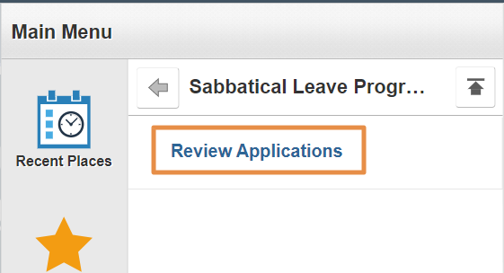
- 4. | Select the required document from the list. | 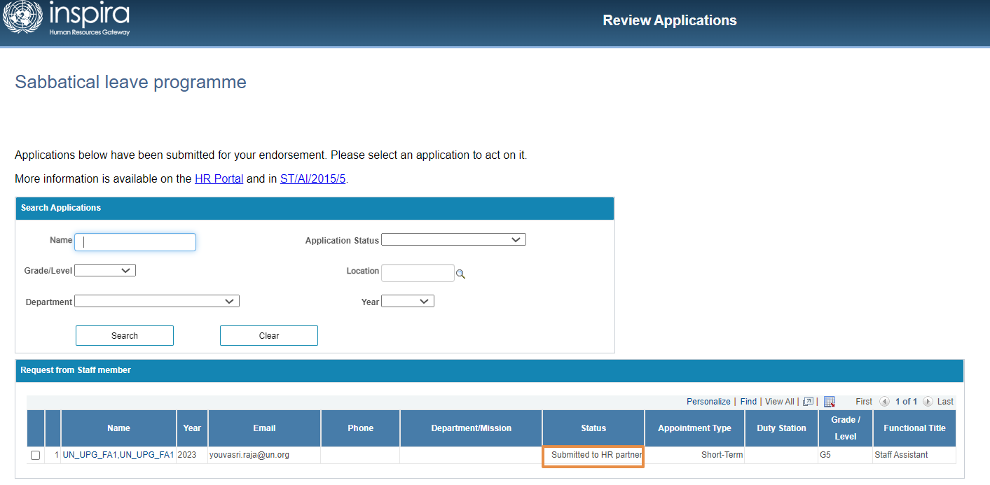
 | HR Partner will be able to review all details of application, namely:  - Personal information  - Background  - Proposal  - Attachment Review & Submit | 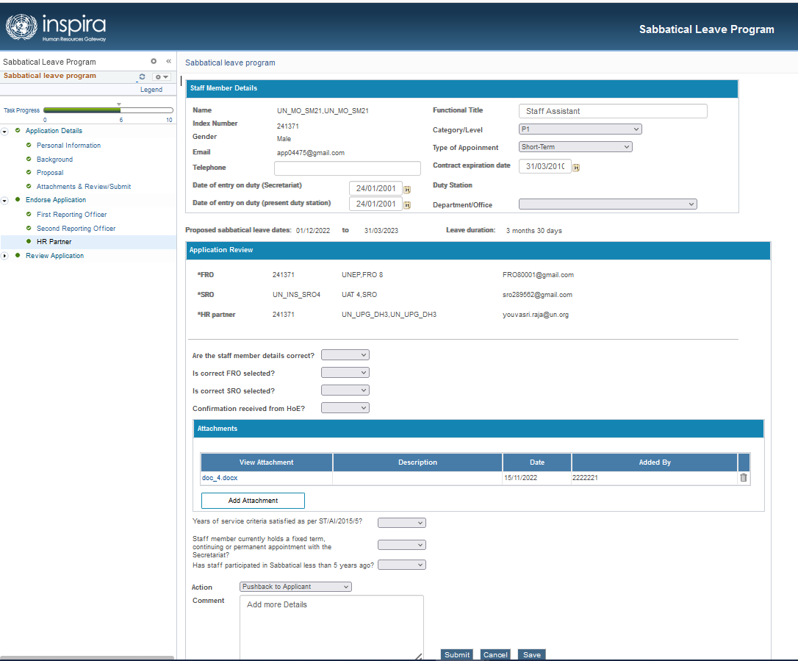
 | Go to HR Partner Section,  Following fields of Staff Member Details are editable by HR for both (external and internal applicant) by clicking “Edit Personal Data” link  - Telephone  - Date of entry on duty (Secretariat)  - Date of entry on duty (present duty station)  - Functional title  - Category / level  - Type of appointment  - Contract expiration date  - Department / office | 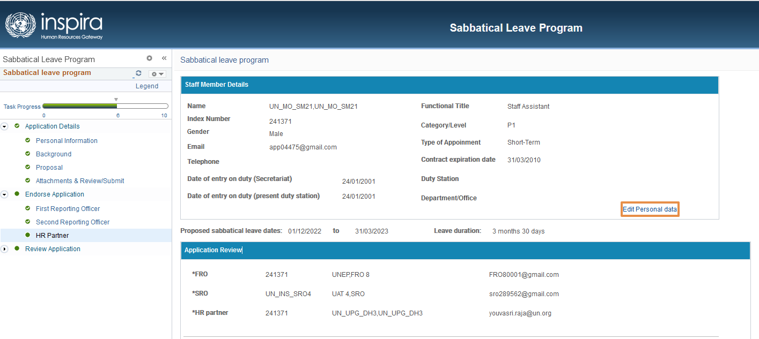  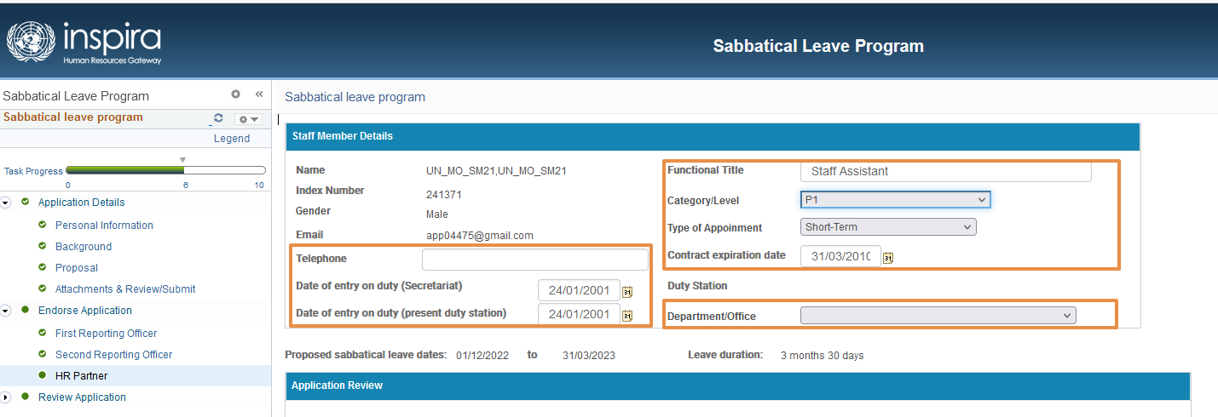
 | Confirmation needed for the following and it need to be YES to proceed to next step:  - Are staff member details, correct?  - Is FRO selected?  - Is SRO selected?  - Confirmation received from HoE? Provide the attachment*  - Years of service criteria satisfied as per ST/AI/2015/5?  - Staff member currently holds a fixed term, continuing or permanent appointment with the secretariat?  - “Has staff participated in Sabbatical less than 5 years ago? It needs to be NO to proceed to next step.  - Selection Action as “Submitted to PM” from the dropdown  - Click submit.  An email will be triggered to Program Manager (PM) | 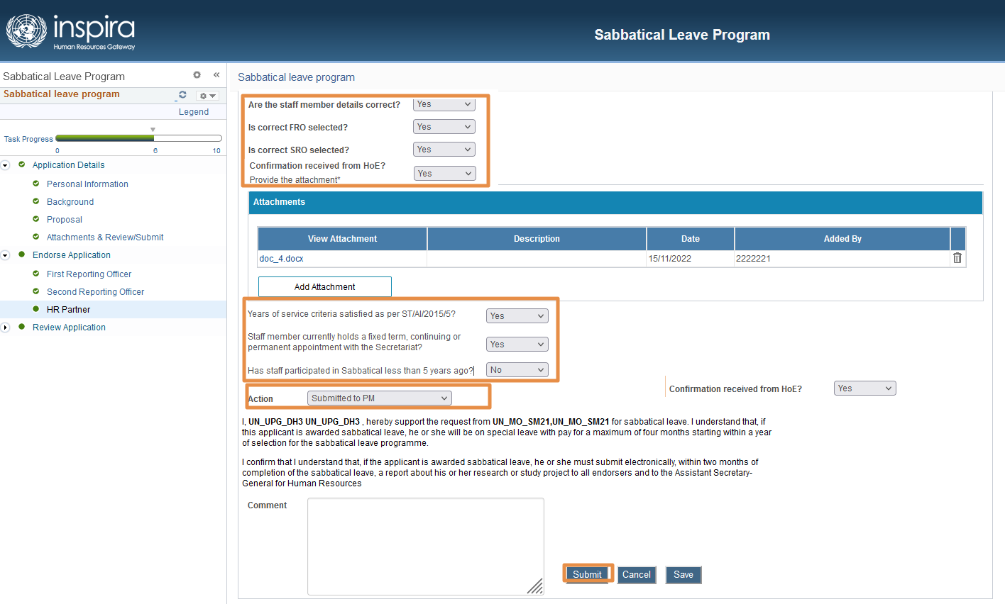

HR Partner Pushback

Step | Step Description
 | Login to Inspira with Username and Password | https://hcmunattrn.opc.oracleoutsourcing.com/psp/UNATHTRN/?cmd=login&languageCd=ENG&
 | Go to Main menu >> Recruit and Manage staff >> Manage My Staff >> Sabbatical leave programme >> Review Applications
 | Select the required application from the list
 | Review all the Application details and navigate to HR Partner section
 | HR pushback to SRO  - Select Action as “Pushback to SRO”  - Enter the comments  - Click Submit  An email will be triggered to SRO. | 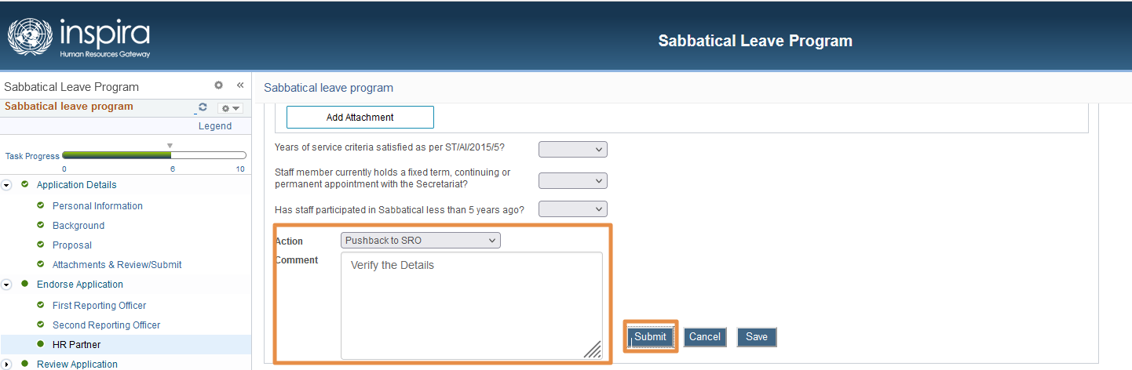
 | HR pushback to FRO  - Select Action as “Pushback to FRO”  - Enter the comments  - Click Submit  An email will be triggered to FRO | 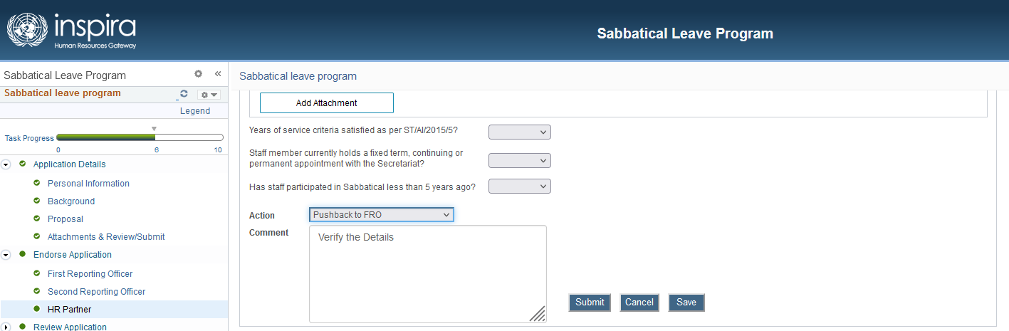
 | HR pushback to Applicant  - Select Action as “Pushback to Applicant”  - Enter the comments  - Click Submit  An email will be triggered to Applicant | 