Activity Guide 4- SRO Approval and Pushback

As SRO

Step | Step Description
 | When the FRO submits the Application to SRO, SRO will receive an email.
 | Login to Inspira with Username and Password | https://hcmunattrn.opc.oracleoutsourcing.com/psp/UNATHTRN/?cmd=login&languageCd=ENG&
 | Go to Main menu >> Recruit and Manage staff >> Manage My Staff >> Sabbatical leave programme >> Review Applications. | 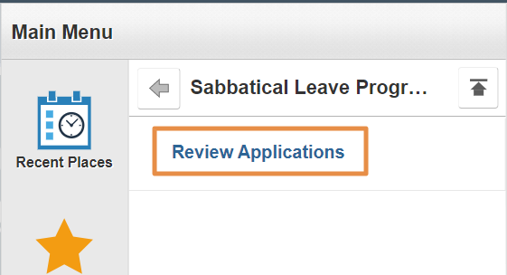
 | Select the required application from the list. | 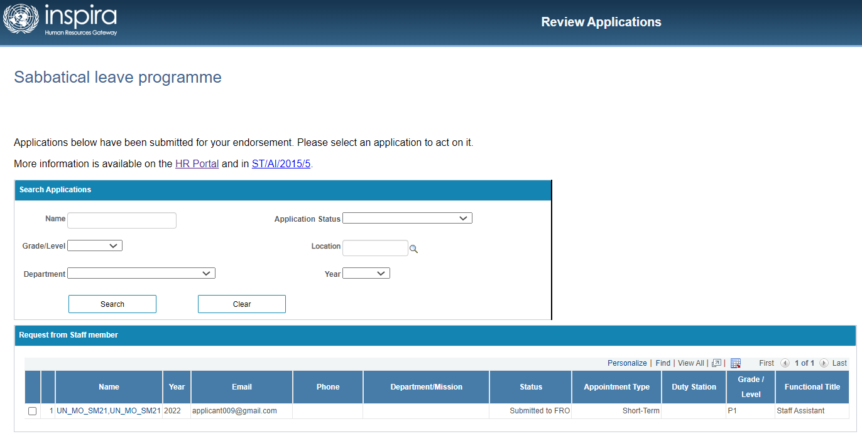
 | SRO can review all details of application, namely:  - Personal information  - Background  - Proposal  - Attachment Review & Submit  Review the Application and navigate to Second Reporting Officer section | 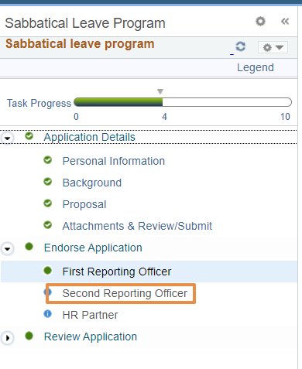
 | Staff Member Details section,  Following fields of Staff Member Details are editable by SRO for both (external and internal applicant) by clicking “Edit Personal Data” link  - Telephone  - Date of entry on duty (Secretariat  - Date of entry on duty (present duty station)  - Functional title  - Category / level  - Type of appointment  - Contract expiration  - Department / office | 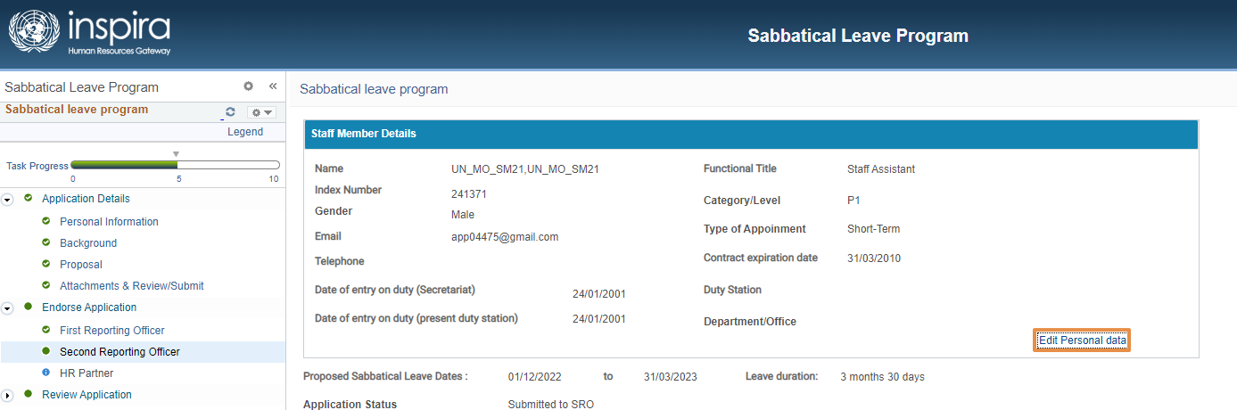  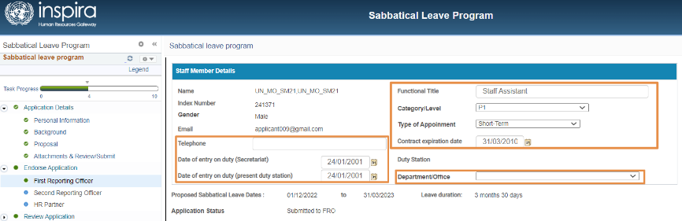
 | Attachments:  Make Attachments, if required.  - SRO is allowed to attach new files as well.  However, SRO will not be able to delete any existing files uploaded by other users. | 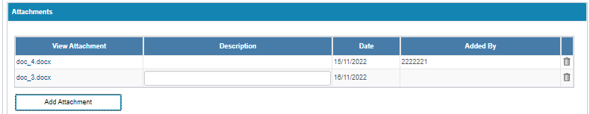
 | - FRO and SRO information will not be editable  - If required, HR Partner can be changed here. | 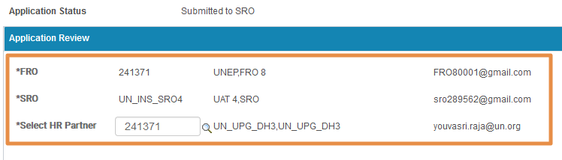
 | SRO to Submit to HR  - Select Action as “Submitted to HR partner”  - Click Submit. | 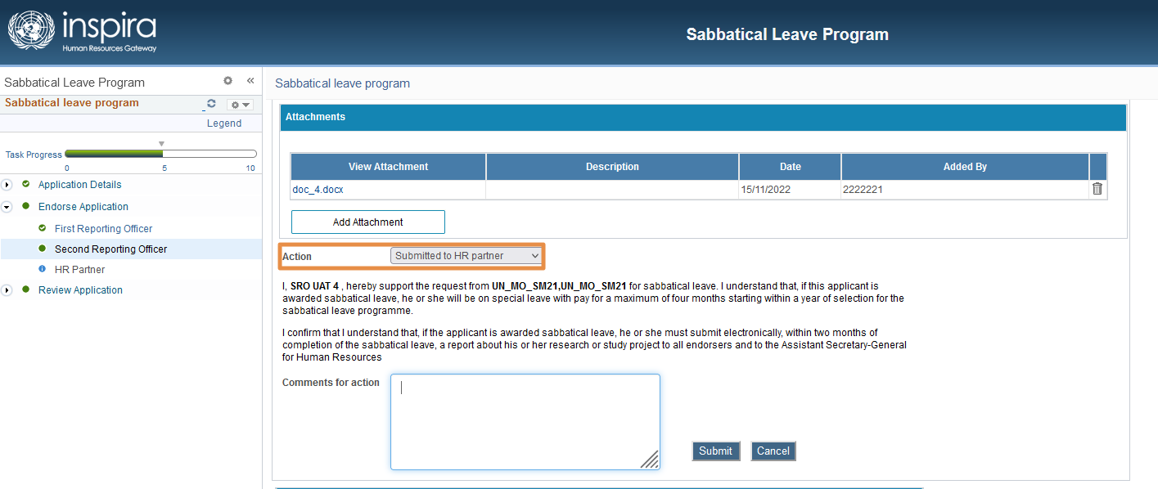
 | IF the SRO or HR is changed by the SRO then while submitting an alert will be shown  Click “Yes” to proceed with submission. | 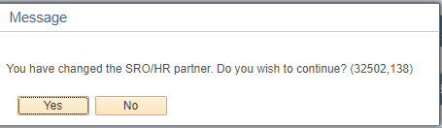
An email will be triggered to HR Partner on SRO’s submission.

Now, the Application status will be changed to “Submitted to HR Partner”.

SRO Pushback

Step | Step Description
 | Login to Inspira with Username and Password | https://hcmunattrn.opc.oracleoutsourcing.com/psp/UNATHTRN/?cmd=login&languageCd=ENG&
 | Go to Main menu >> Recruit and Manage staff >> Manage My Staff >> Sabbatical leave programme >> Review Applications.
 | Select the required application from the list.
 | Review the Application and navigate to Second Reporting Officer section
 | SRO Pushback to Applicant  - Action must be selected from the dropdown as “Pushback to Applicant”  - Comments are mandatory.  - Click Submit.  Confirmation message will appear. Click “Yes”  Email notification will be triggered to “Applicant” | 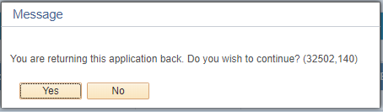
 | SRO Pushback to FRO  - Select Action as “Pushback to FRO” from the dropdown  - Enter the Comments  - Click Submit.  - Confirmation message appear, click “Yes”  Email notification will be triggered to “FRO” | 