Activity Guide 3- FRO Approval or FRO Pushback

As FRO

Step | Step Description
 | When the Applicant submits the Application to FRO, FRO will receive an email.
 | Login to Inspira with Username and Password | https://hcmunattrn.opc.oracleoutsourcing.com/psp/UNATHTRN/?cmd=login&languageCd=ENG&
 | Go to Main menu >> Recruit and Manage staff >> Manage My Staff >> Sabbatical leave programme >> Review Applications | 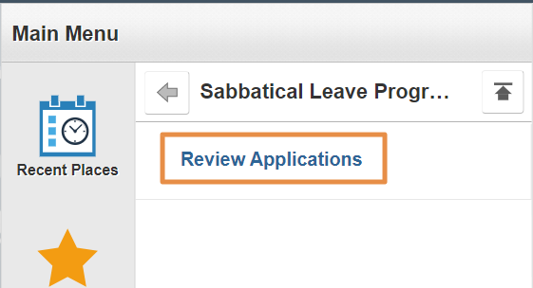
 | - Select the required application from the list. | 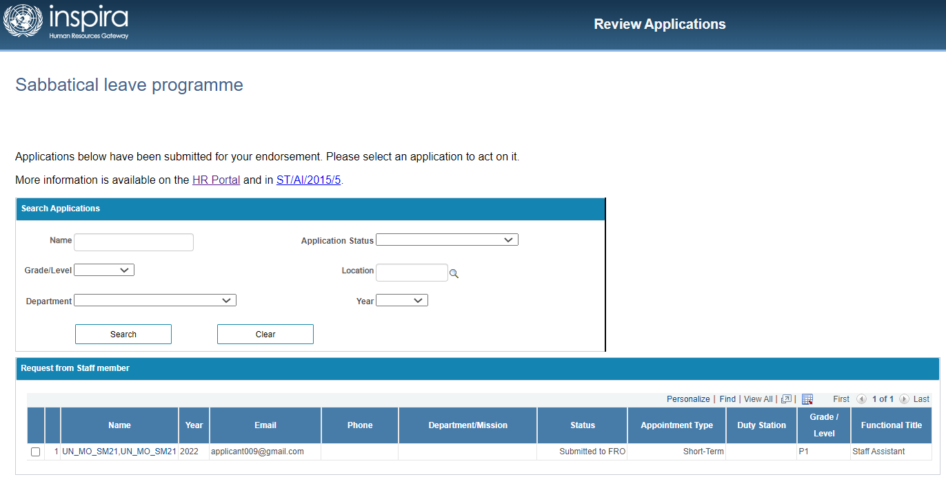
 | - FRO can review all details of application, namely:  - Personal information  - Background  - Proposal  - Attachment Review & Submit  Review the Application and navigate to First Reporting Officer section | 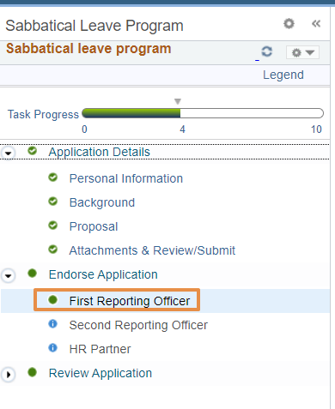
6 | Staff Member Details section,  Following fields of Staff Member Details are editable by FRO for both (external and internal applicant) by clicking “Edit Personal Data” link  - Telephone  - Date of entry on duty (Secretariat  - Date of entry on duty (present duty station)  - Functional title  - Category / level  - Type of appointment  - Contract expiration  - Department / office | 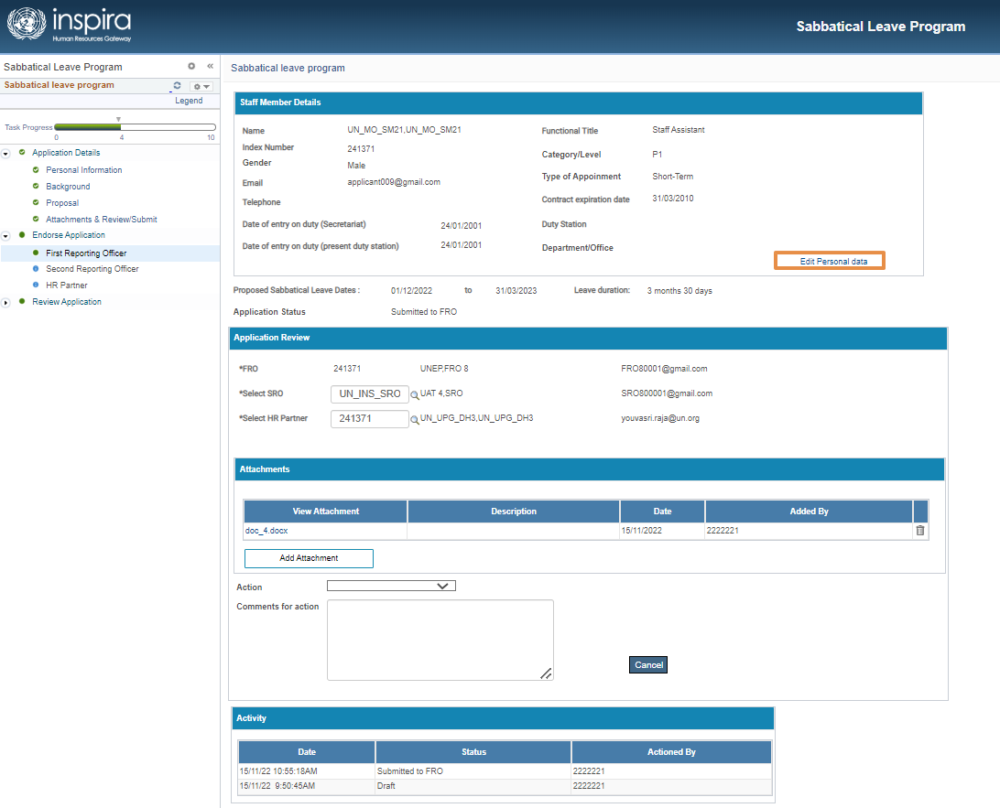  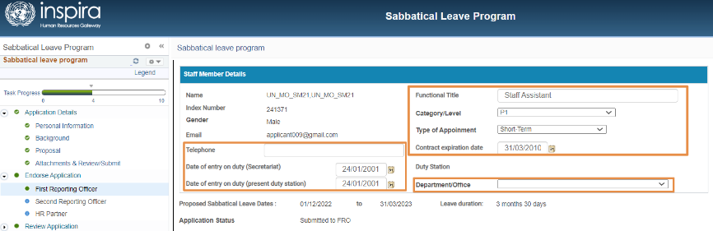
7 | Attachments:  Make Attachments, if required.  - FRO is allowed to attach new files as well.  However, FRO will not be able to delete any existing files uploaded by other users. | 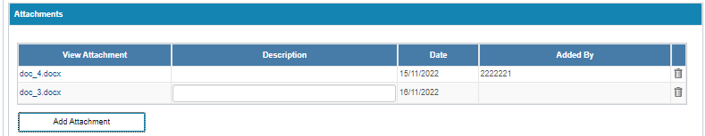
8 | - FRO information will not be editable  - If required, SRO & HR Partner can be changed here. | 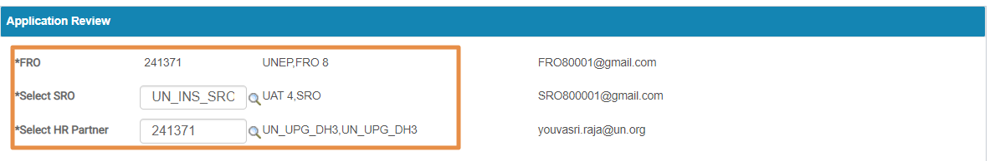
9 | To Submit to SRO,  - Select the Action as “Submitted to SRO” and If required, add comment (non-mandatory)  - Click save  - Click Submit. | 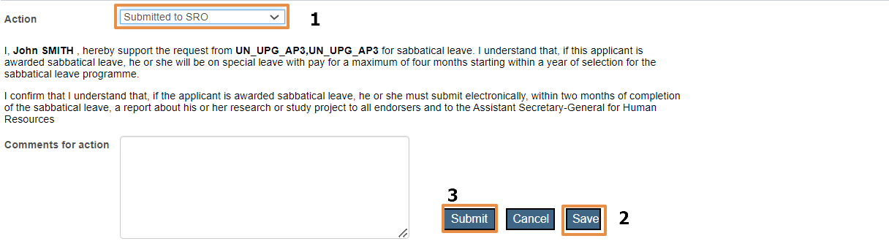
10 | IF the SRO or HR is changed by the FRO then while submitting an alert will be shown  Click “Yes” to proceed with submission. | 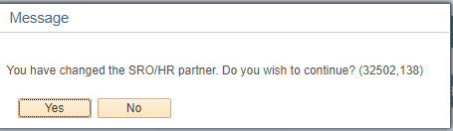
11 | An email will be triggered to SRO on FRO’s submission.  Now, the Application status will be changed to “Submitted to SRO”.

FRO Pushback

Step | Step Description
- 1 | Login to Inspira with Username and Password | https://hcmunattrn.opc.oracleoutsourcing.com/psp/UNATHTRN/?cmd=login&languageCd=ENG&
- 2 | Go to Main menu >> Recruit and Manage staff >> Manage My Staff >> Sabbatical leave programme >> Review Applications
 | Select the required application from the list.
 | Review the Application and navigate to First Reporting Officer section
 | To Pushback:  - Action must be selected from the dropdown as “Pushback to Applicant”  - Comments are mandatory.  - Click Submit.  Confirmation message will appear. Click “Yes”  An email will be triggered to the Staff regarding the pushback | 