Activity Guide 2- Internal Applicant’s Application Creation

As Internal Applicant

Step | Step Description
 | Login to Inspira with the Internal Applicant Username and Password | https://hcmunattrn.opc.oracleoutsourcing.com/psp/UNATHTRN/?cmd=login&languageCd=ENG&
 | Go to Main menu >> My Career and Learning>> Sabbatical leave programme >> My Applications (new) | 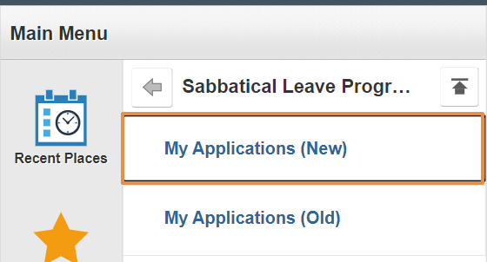
 | Sabbatical Leave Programme page appears,  - Select the Year from drop down  - Click Start Application button. | 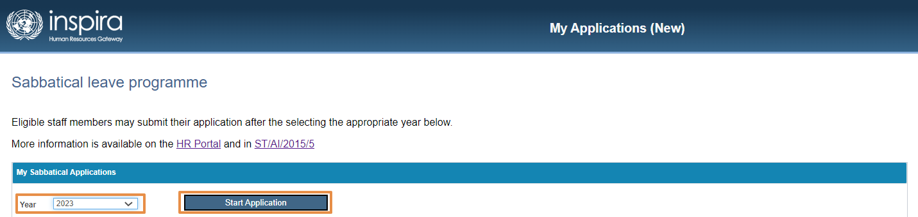
 | Under Application Details,  Go to Personal Information,  - Read and complete the Additional Details section  - Select FRO, SRO and HR Partner  - Click Save.  Activity Section,  It will capture all the activities along with the status | 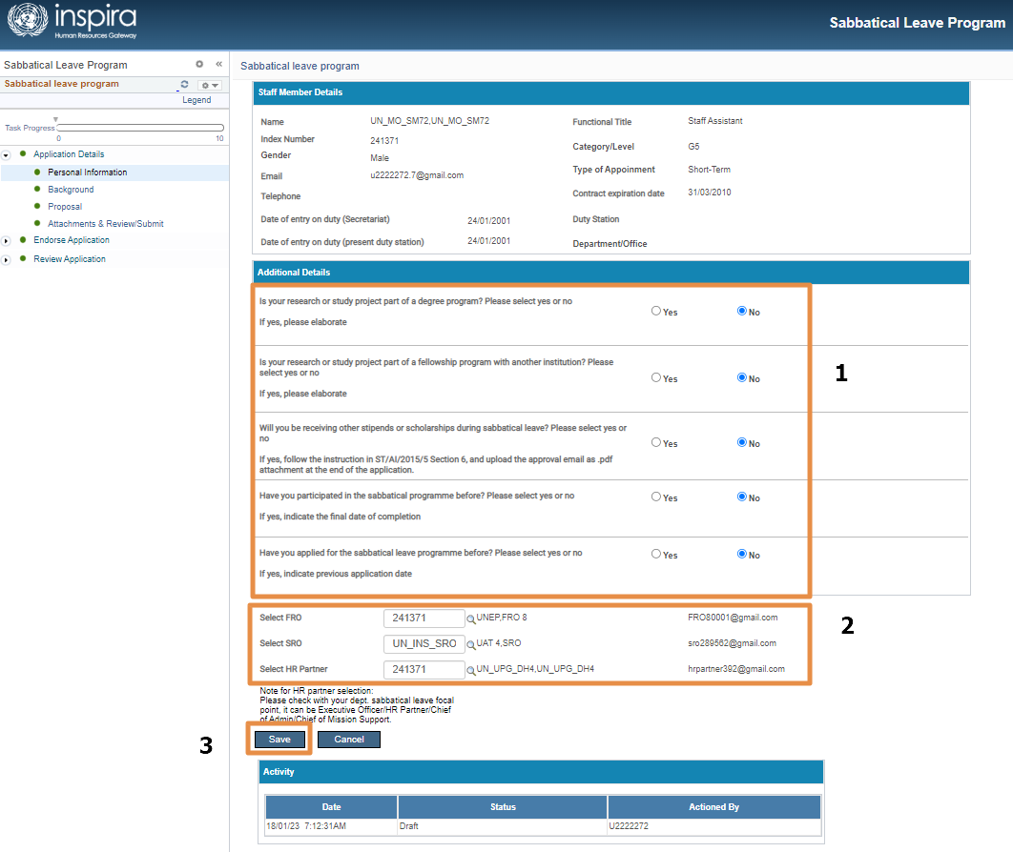
 | Go to Background Section,  1.Complete the Background section.  2. Complete the Placement section.  3. Click Save. | 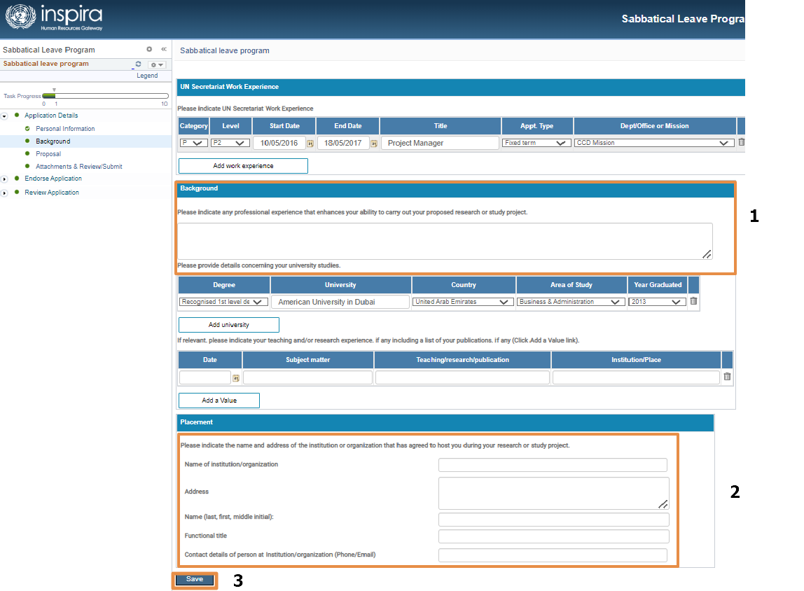
 | Go to Proposal section  - Complete all the Additional Details which are mandatory  - Complete the proposed date of study/project  - Click Save | 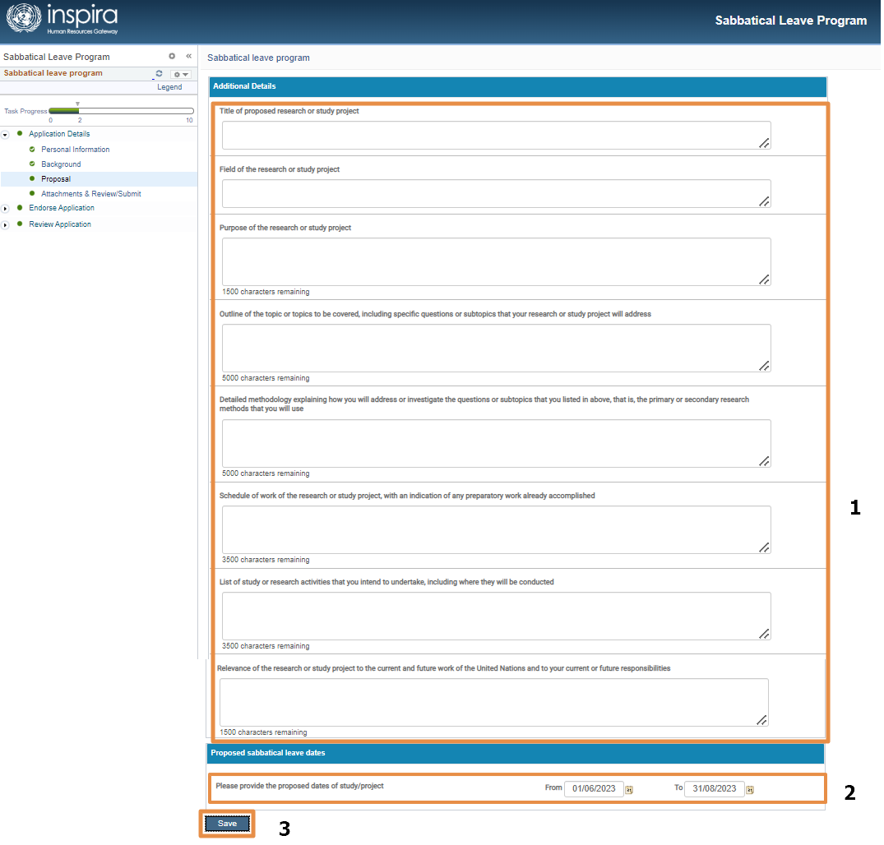
 | Go to the Attachment & Review/Submit Page  - Add the Attachments by clicking the “Add Attachment” button  - Click “Browse” to select the file  - Click “Upload” button  - Click “Save” button  - Check the Applicant Checklist check box  - Click Submit Application.  Note:  - At least one attachment is mandatory  - Every time Applicant checklist must be selected before submitting. | 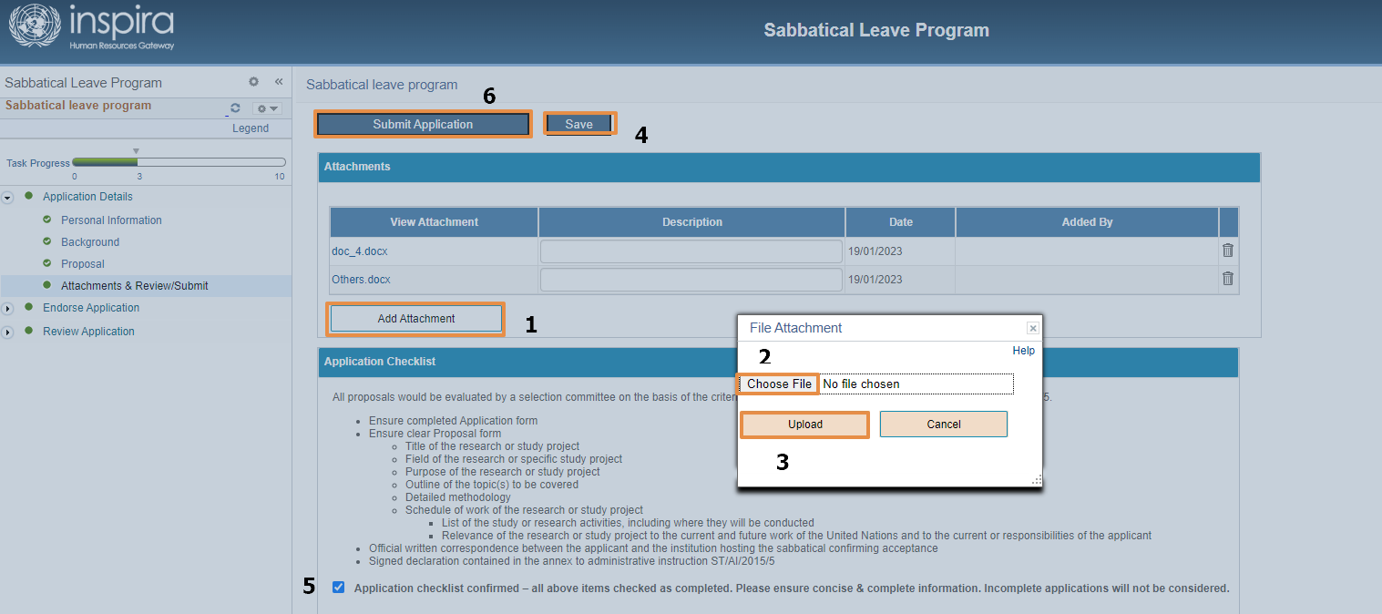
 | EMAIL:  An email will be triggered to FRO on Application submission by Applicant. | 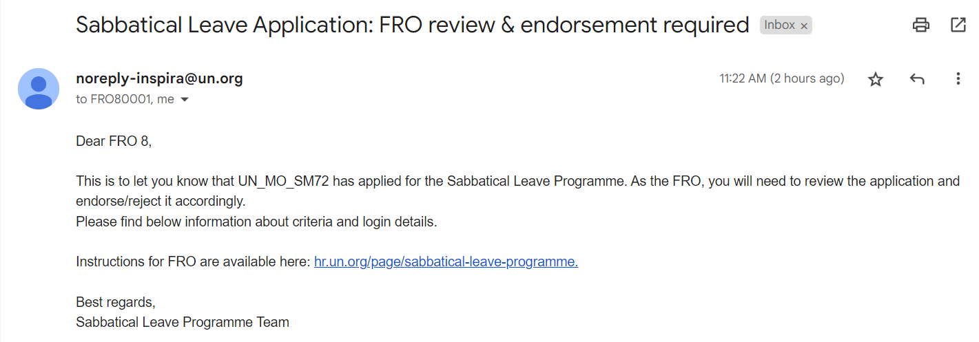
 | After Submitting, the status of the Application will be “Submitted to FRO”  And the Activity status will also get updated | 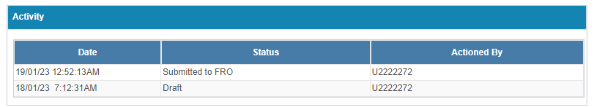
 | Before submitting the status of the application will be “Draft” | 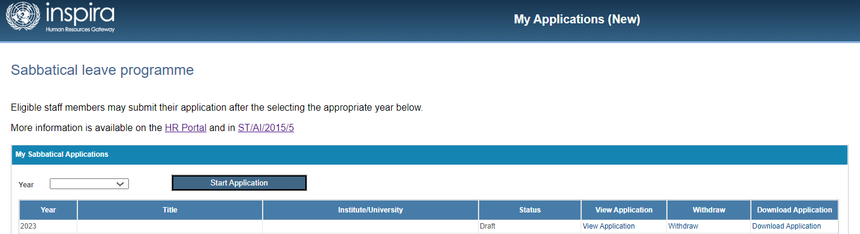

Note:

Resubmit the Application:

If the Application is pushed back by FRO or SRO or HR Partner or Program Manager then, the Applicant can resubmit the application after making the necessary changes by following the steps from 1 to 10.

Application view:

Once when the Application status is changed to “In Review” then the Applicant cannot view or withdraw the Application. They can only Download the Application

