Activity Guide 1- External Applicant’s Application Creation

As External Applicant

Step | Step Description
 | Login to Inspira with the Applicant Username and Password | https://hcmunattrn.opc.oracleoutsourcing.com/psp/UNATHTRN/?cmd=login&languageCd=ENG&
 | Go to Main Menu >> Sabbatical - External >> My Applications | 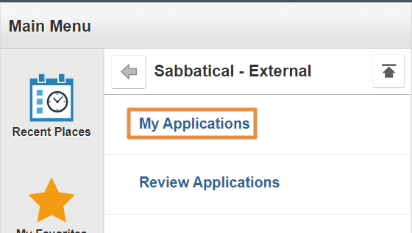
 | Sabbatical Leave Programme page appears,  - Select the Year from drop down  - Click Start Application button | 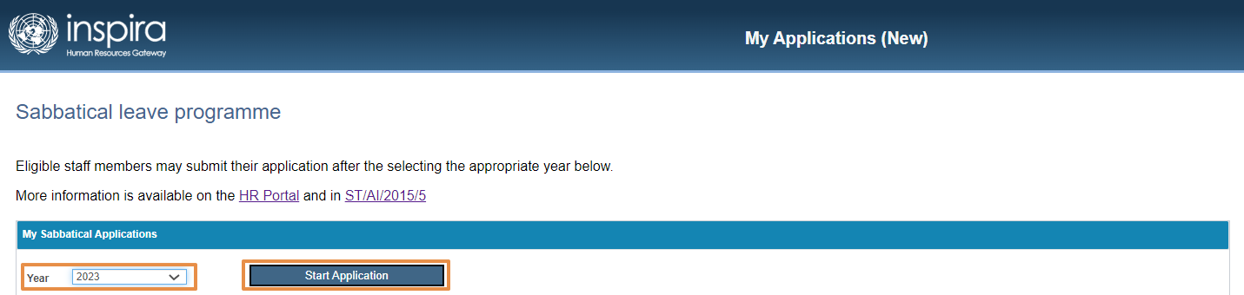
 | Under Application Details,  Go to Personal Information,  In Staff Member Details:  - External user can enter all fields in this section.  - Gender  - Email  - Telephone  - Date of entry on duty (Secretariat)  - Date of entry on duty (present duty station)  - Functional title  - Category / level  - Type of appointment  - Contract expiration date  - Duty station  - Department / office.  - Read and enter the Additional Details section  - Select FRO, SRO and HR Partner  - Click Save.  Activity Section,  It will capture all the activities along with the status | 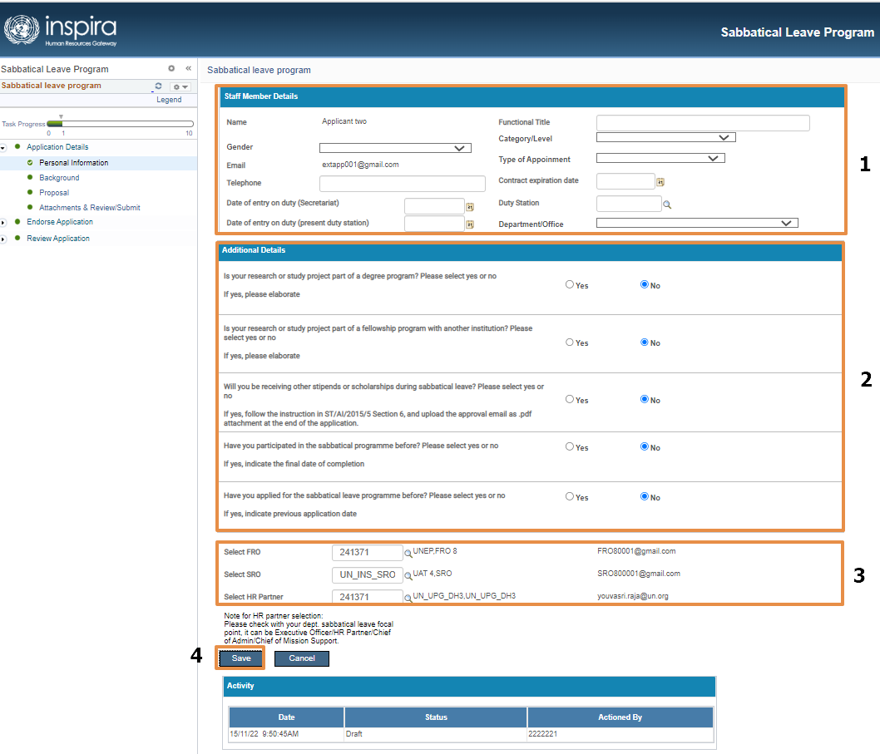
 | Go to Background Section,  1.Complete the Background section.  2. Complete the Placement section.  3. Click Save. | 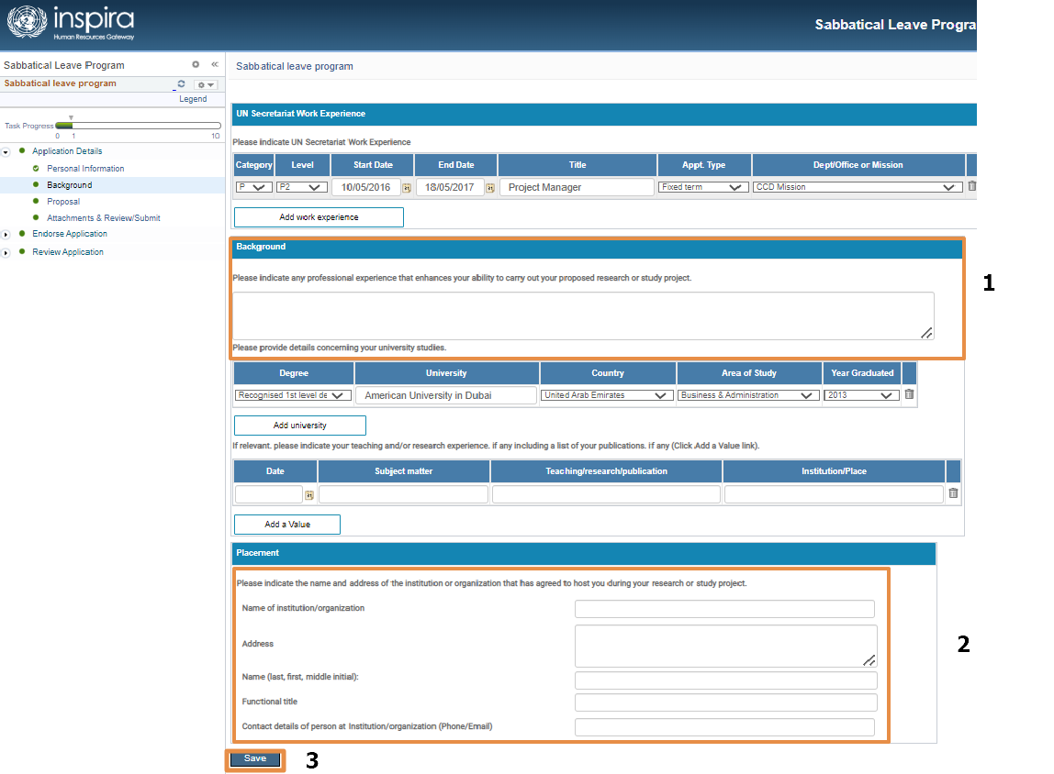
 | Go to Proposal section  - Complete all the Additional Details which are mandatory  - Complete the proposed date of study/project  - Click Save | 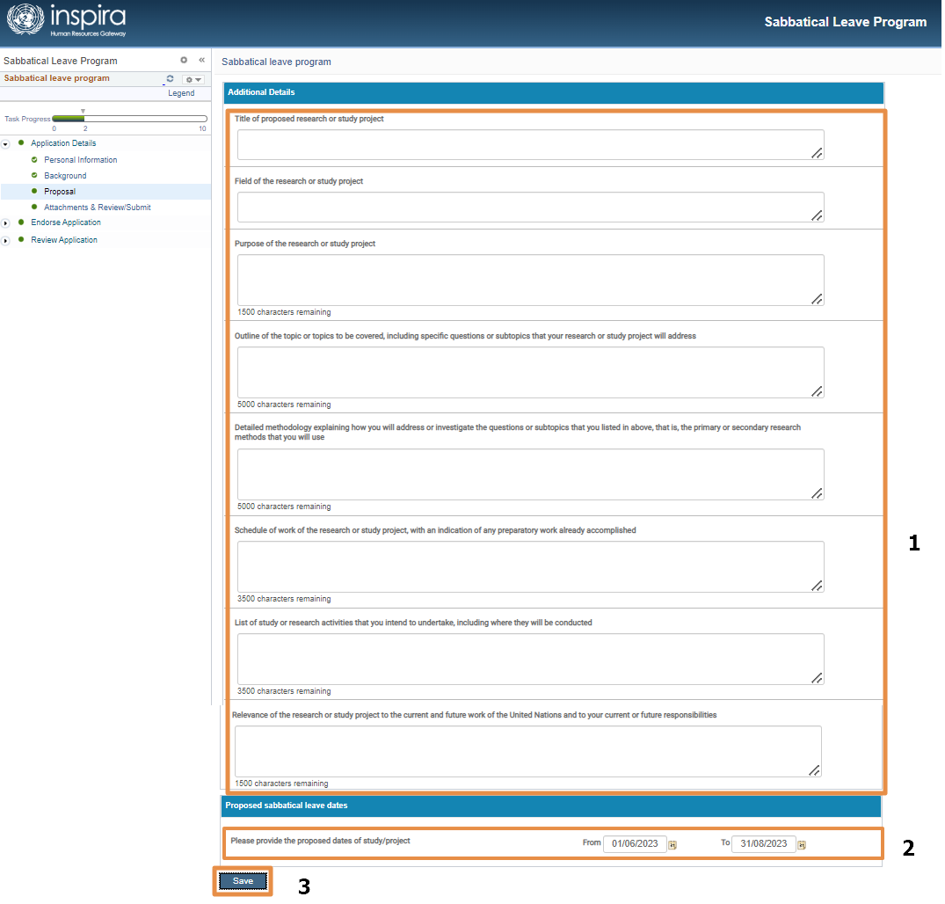
 | Go to the Attachment & Review/Submit Page  - Add the Attachments by clicking the Attachment button  - Click “Browse” to select the file  - Click Upload button  - Click Save.  - Check the Applicant Checklist check box  - Click Submit Application.  Note:  - At least one attachment is mandatory  - Every time Applicant checklist must be selected before submitting. | 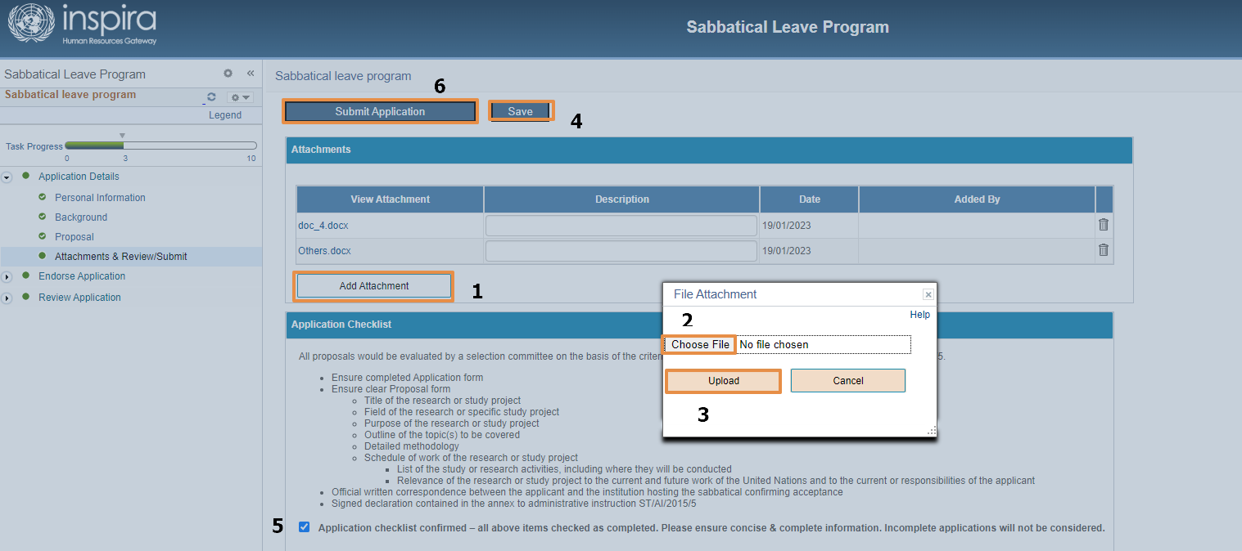
 | EMAIL:  An email will be triggered to FRO on Application submission by Applicant. | 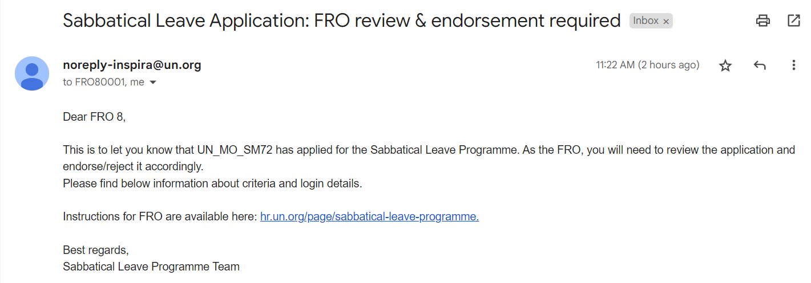
 | Before submitting, the status of the application will be “Draft” | 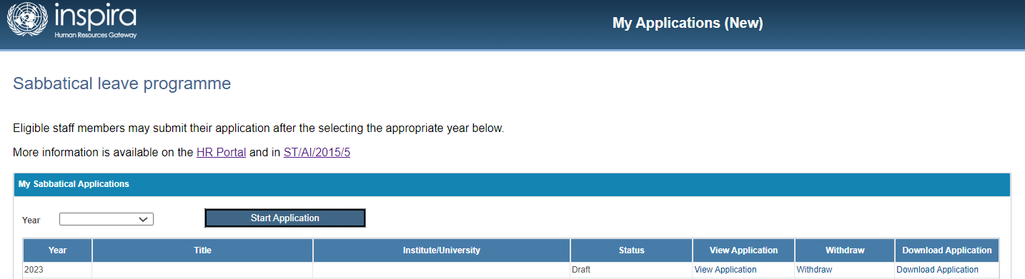
 | After Submitting the Application, status of the Application will be “Submitted to FRO”  And the Activity status will also get updated | 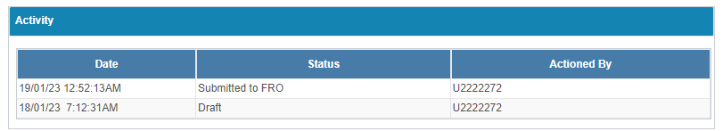

Note:

Resubmit the Application:

If the Application is pushed back by FRO or SRO or HR Partner or Program Manager then, the Applicant can resubmit the application after making the necessary changes by following the steps from 1 to 10.

Application view:

Once when the Application status is changed to “In Review” then the Applicant cannot view or withdraw the Application. They can only Download the Application

